**Introduction to Behavioral Finance**

The financial theory based on Modern Portfolio Theory (Markowitz, 1952) and Capital Asset Pricing Model (Sharpe, 1964) has long shaped the way in which academics and practitioners analyze investment performance. This theory is based on the notion that investors act rationally and consider all available information in the decision- making process, and hence investment markets are efficient, reflecting all available information in security prices. In 1956, Noble Prize Laureate Vernon Smith presented an opposing view, when he was the first to introduce the concept of behavioral finance.

Behavioral finance is part of finance that seeks to understand and explain the systematic financial market implications of psychological decision processes. It utilizes knowledge of cognitive psychology, social sciences and even anthropology to explain irrational investor behavior that is not being captured by the traditional rational based models. In essence, the field of behavioral finance attempts to better understand and explain how emotions and cognitive errors influence investors and the decision-making process and then ultimately moves in financial markets.

Behavioral finance researchers have uncovered a surprisingly large amount of evidence of irrationality and repeated errors in judgment. Kahneman and Tversky (1979), Shefrin and Statman (1994), Shiller (1995) and Shleifer (2000) are among the leading researchers that have utilized theories of psychology and other social sciences to shed light on the efficiency (or lack of efficiency) of financial markets as well as explain many stock market anomalies, bubbles and crashes.

**Stock Market Crash of October 1987**

Stock market crashes were nothing new in 1987, but previous financial crises, e.g., in 1929, often reflected fundamental (economic and financial) problems in the U.S. economy.

During the five trading sessions from Tuesday, October 13 to Monday, October 19, 1987, the Dow Jones Industrial Average lost a third of its value and about $1 trillion of U.S. stock market value was wiped out. The losses culminated in a panic-stricken 22.6% decline in the Dow on “Black Monday,” October 19 (see charts on next page).

To this day, no one really knows for sure why the markets chose Oct. 19 to crash. But for whatever reason, the mood on Wall Street shifted suddenly, and everyone tried to sell stocks at once.

Finance Professor Paolo Pasquariello of the University of Michigan's Ross School of Business noted that the mystery behind 1987 prompted scholars to come up with new ways of studying financial crises. Instead of just focusing on economic fundamentals, they put more attention on the "market microstructure," the ways people trade and the process by which the market forms asset prices. "Something just clicked," wrote Chris Lamoureux, finance professor at the University of Arizona. "It would be like a whole crowded theater trying to get out of one exit door." Behavioral finance professor Hersh Shefrin, at Santa Clara University, wrote that investors believe they understand the world. In a crisis, "something dramatically different happens and we lose our confidence. Panic is basically a loss of self-control. Fear takes over."

**Dow Jones Industrial Average, September 1, 1987 – December 31, 1987**

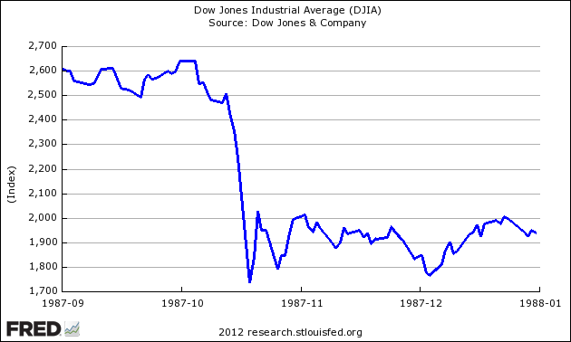

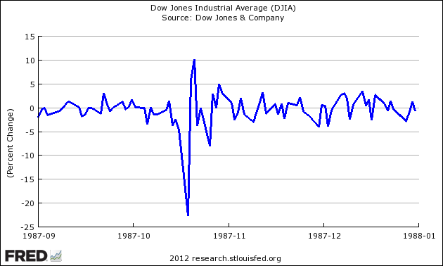

**Behavioral Finance Studies**

While behavioral finance studies have identified a number of “emotional” factors influencing the decisions of investors, one common factor is overconfidence.

Overconfidence is an overestimation of one's skills, abilities, and knowledge. With investor behavior, this overconfidence can lead to illusions of control that result in biased judgments, investing too much in investments about which they know too little, and taking undue risks. Overconfidence can also mask errors investors make. So instead of learning from their errors, investors attribute poor investment results not to their own mistakes, but to some other cause over which they have no control.

Another factor which behavioral finance studies have identified is referred to as rationalization in decision making. Rationalization suggests that investors search for and rely on information that supports their decisions. The tendency to give too much importance to information that confirms one’s impressions or preferences is called confirmation bias. Rationalization suggests that “bad news” and facts that might challenge one’s opinions tend to be ignored.

Loss aversion refers to the notion that investors hate to take losses. While this seems obvious, the degree to which investors are averse to taking losses was illuminated in a 1979 study by Kahneman and Tversky. They found that a loss has about 2.5 times the impact of a gain of the same magnitude. Loss aversion, which is related to fear of regret, explains why many investors will not sell anything at a loss. Selling at a loss not only admits a mistake, but also ends any hope of at least getting back even. In the meantime, better investments are passed by while waiting for the stock to rebound.

Recency refers to the problem of putting too much weight on current events or data and not enough weight on past, historic trends. According to recency, many investors expect the market to continue rising in a current bull market; likewise, these same investors often expect a current bear market to get worse. Recency is shown in momentum investing when investors buy “hot” stocks simply on the basis of their recent strong performance.

Anchoring refers to the tendency to hold to certain beliefs even when faced with new information that should alter those beliefs, thereby creating, in effect, tunnel vision. In other words, investors start at an initial mental reference point based on past experience. This might lead to overweighting irrelevant data or slowly adjusting as they receive additional information. As applied to the announcement of a company’s earnings, anchoring results in security analysts underreacting to unexpected earnings announcements.

**Additional Information:**

For a very complete list of behavioral finance studies you are encouraged to link to: <http://www.behaviouralfinance.net/>