**Financial Markets; This Old Stock Market**

*March 15, 2012, The Economist*

AGING populations in America and Europe raise many economic concerns. A popular one is whether aging baby boomers will tank the stock market. That’s story in this [*Wall Street Journal*](http://online.wsj.com/article/SB10001424052970204795304577223632111866416.html?mod=WSJ_hp_mostpop_read) article, which says that when baby boomers bought stock to fund their retirement, that drove up share prices in the 1990s. Now, on the cusp of retirement, they will sell their shares so prices must fall. This theory appears to be confirmed by a figure from the [San Francisco Fed](http://www.frbsf.org/publications/economics/letter/2011/el2011-26.html), which shows a strong correlation between the price/earnings ratio and what they call the M/O ratio, the ratio of people age 40 to 49 to people age 60 to 69.

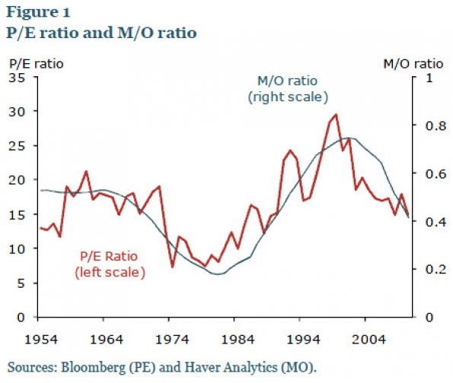

Does this mean we’re doomed for a bearish decade? Perhaps, but I am not convinced. First it’s unlikely that each cohort of retiring baby boomers will sell shares en-masse. Most retirees don’t annuitize or hold a significant amount of inflation-linked securities, so many will probably keep some equity in their portfolio to hedge against inflation in retirement. And if investors expect liquidity to dry up, wouldn’t that already be reflected in prices? Perhaps the number of equity buyers won’t fall. Many boomers don’t own stock; according to the [2007 Survey of Consumer Finance](http://www.federalreserve.gov/econresdata/scf/files/2007_scf09.pdf) about 60% of households with a boomer head own some stock. If owning equity becomes more popular then the supply of buyers could increase, even as the population ages. Most people only own shares through their retirement account, so the growing ubiquity of private pension accounts (which covers a larger share of the American population than defined-benefit plans ever did) could increase stock market participation.

Global markets are also more integrated and it’s the global population of investors that matters. But people and institutions tend to have home bias when it comes to their stock portfolio, so I’m not sure we can count on Chinese savers to buy American stocks.

Besides, the supply and demand story is not the only thing that determines asset pricing. It may in the short-run, but over the long-run there are other factors. Many of the economic models that show decreased demand resulting in lower stock prices assume a [fixed capital stock](http://piketty.pse.ens.fr/fichiers/enseig/ecoineg/articl/PoterbaRESta2001.pdf) or capital structure. With a smaller labor force participation rate or population of share buyers, why would the number of shares stay the same? Firms might buy back shares to keep the price high or there may be fewer firms because of mergers or closures. Or if firms can’t raise much capital in the equity market they might explore other methods of finance. And if retirees do hold on to their equities they might desire stocks that pay dividends to finance their consumption.

The supply and demand story also ignores the risk. Stock returns are determined by the equity risk premium above bond returns. The risk premium is how much investors are compensated for holding an asset that’s riskier than a bond. So a falling stock price demographic scenario presumes that younger generations are more risk-tolerant. Perhaps that’s true; risk tolerance can be [generation-specific](http://www.econ.yale.edu/%7Eshiller/behmacro/2007-11/malmendier.pdf). Children of the Depression were more wary of the stock-market than baby boomers. But if generational risk tolerance determines share prices you’d see higher stock prices in the 1960s and 70s, when Depression children were in their prime saving years, and lower ones in the 1990s, when baby boomers were saving; the opposite happened.

Another way to look at equity prices is as reflecting the discounted value of future cash flows of a company, or future profitability/productivity. That will be determined by the size of the labour force and future gains in productivity from technological innovations. This is the demographic issue that troubles me. As populations age, America and Europe will divert an increasing share of GDP to the old, rather than developing the skills of the young, through state pensions and health care. This might undermine future productivity. [Megan McArdle](http://www.theatlantic.com/magazine/archive/2012/04/europe-8217-s-real-crisis/8915/) frets that countries with older populations will experience slower growth because older workers may be less innovative and risk-taking. That’s not encouraging but need not be our fate; one never knows what new innovation has the potential to transform an economy. Years of history suggest each generation is richer and more productive than the last; why should our future be any different?

It is not clear what demographics will mean for the share prices. The story is more complicated than supply and demand of share buyers. The stock market in the future will be determined by global attitudes toward risk, retirement, and productivity. Whether or not this will result in decades of bear markets is anyone’s guess.