Case Study: Argentina Currency Crisis of 2002

During the 1980s, the Argentina economy was characterized by hyperinflation, international indebtedness and debt defaults, and recessions. In the early 1990s, the Argentina government introduced a series of economic and monetary reforms, including fixing the Argentina peso to the U.S. dollar at a rate of 1 to 1. Under this arrangement, Argentina could only print pesos if it had U.S. dollar backings (note: this monetary arrangement is referred to as a currency board).

Under this currency board arrangement, Argentina was only able to expand the peso portion of its money supply in relation to its net inflows of U.S. dollars (resulting from trade growth). The policy’s impact on inflation was almost immediate; the inflation rate went from 2,300% in 1990 to 25% in 1992 and to less than one percent b y 1996 (see exhibit 1).

The Argentina economy, however, did not fare as well. The restrictive currency board policy resulted in rising unemployment (up to 16% in 1996) and slow economy growth (recessions in 1995 and 1999-2000).

As part of the 1991 reforms, the Argentina government permitted residents to hold their money deposits in banks in either pesos or U.S. dollars. This was seen as promoting confidence and discipline in the banking and political system.

However, the recession which began in 1999 proved to be the demise of the currency board and the exchange rate regime. The recession which lasted through 2001, resulted in massive government deficits and a general perception that the peso had become overvalued (recall the fixed rate was 1 to 1).

As economic conditions continued to deteriorate and as the peso’s worth become more and more uncertain, a massive conversion of pesos into U.S. dollars within the Argentina economy began; eventually leading to capital flight out of the country itself. The government responded by closing all banks on December 1, 2001 and then limiting the withdrawal of funds from banks and the conversion of pesos into dollars.

The social repercussions of the government’s response were dramatic. Riots took place in the streets of Buenos Aires in December. The President, Fernando de la Rua was driven from office and his successor, Adolfo Rodriguez Saa, was also forced out of office after one week on the job.

Saa was succeeded by Eduardo Duhalde, who on Sunday, January 6, 2002, in his first act of presidency, devalued the peso from Ps1/1$ to Ps1.40/1$. The markets were not impressed with this new rate and on Monday, February 11, 2002, the Argentina government moved to a floating rate regime. Over the course of time, the peso began a period of depreciation, eventually settling around 3.5 (see exhibit 2).

Exhibit 1: Inflation in Argentina, 1980 - 2001
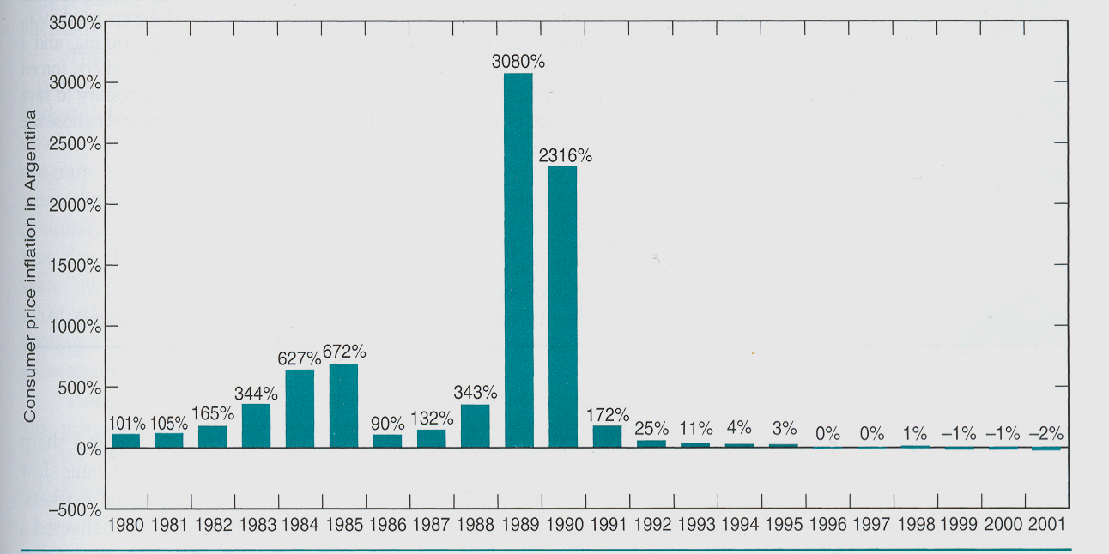

Exhibit 2: Peso Exchange Rate, January 2001 – December 2002



