Business Plan


Table of Contents

Executive Summary 2
Private Label Affinity Card 3
Personalization & Privacy Technology 4
The Teen Market 5
Competition -- Teen Payment Solutions 6
How WallyCard Works 7
Distribution Channels 8
Sales Funnel 9
Revenue Model 10
Revenue Model 11
Offering 12
Competitive Advantage 13
Management Team 14

The WallyCard business plan is intended solely for informational purposes. The information contained herein is believed to be reliable, but the management team makes no representations or warranties with respect to this information. The financial projections that are part of this plan represent estimates based on extensive research and on assumptions considered reasonable, but they are of course not guaranteed. The contents of this plan are confidential and are not to be reproduced without express written consent from WallyCard.

Executive Summary

The Opportunity. In 1999, teens spent $153 billion at traditional brick and mortar stores. While 8.3 million of them used the Internet, few made purchases online. Regulatory issues deny teens under the age of 18 access to credit cards without direct parental involvement. Internet retailers and portals have spent millions trying to reach the free-spending and net-savvy teen audience. WallyCard's stored value Visa solution converts the same lucrative audience into paying customers.

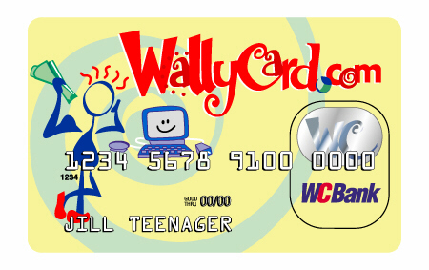

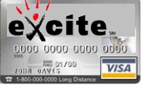
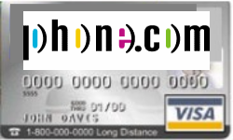
The Solution.
- Prepaid stored value Visa card
- Private Label Card
- The WallyCard
- Activated online or at retail locations

The Difference.
- Private label strategy leverages existing teen customer base of both online portals and brick and mortar retail stores (low customer acquisition costs).
- Registration engine that safeguards teen information while providing opt-in, 1:1 marketing opportunities with demographic, clickstream and transactional data, online & offline.
- A bundled payment mechanism for teenage wireless customers using WAP-enabled phones.

Partnerships. WallyCard’s partnerships with Prepaid Technology, Total System, Columbus Bank & Trust, Visa and XOR enables the back-end processing, card fulfillment, payment processing, rewards program, and account hosting for WallyCard’s private label partners. In addition, WallyCard has established a partnership with PrivaSeek to offer consumer privacy protection to the cardholders while enabling opt-in data sharing and 1:1 marketing functionality.

The Revenue. WallyCard receives revenue from private label clients, transaction fees, and the sale of teenage consumer data on an opt-in basis. Private label revenues consist of a one-time installation fee and recurring monthly charges for use of the WallyCard stored value infrastructure. Transaction fees represent interest on ongoing balances and other network usage fees. In year four, WallyCard expects to recognize revenues of approximately $76 million and net income of $12 million.

The Offering. WallyCard is raising $3 million for its first round of financing. WallyCard projects a return of thirty times the initial investment. Exit strategies include an initial public offering or an acquisition by a financial institution, or Internet commerce company.

The Team. The President Nathan Foran has six years of entrepreneurial experience between founding two companies, and has also served as a consultant to software companies in Silicon Valley. Foran also has worked at venture capital firms and helped to close two deals totaling $11 million in private financing. Chief Marketing Officer Lisa Ferrari traveled across the U.S. as an associate brand manager for Reebok, immersing herself in the lifestyles, cultures and behaviors of trend-setting teenagers. Jeff Finkelstein, the Chief Information Officer, worked as a principle for Entrepreneurial Solutions, LLC and brings technical management skills to the team. CFO Andrew Wilson is a Certified Public Accountant who worked with Ernst & Young as well as with a Colorado-based venture capital firm.

Board of Advisors. Peter Behrendt, Retired CEO of Exabyte; Steve Lucas, CIO of PrivaSeek; David Melancon, Chief Marketing Officer, netLibrary; and Patrick Scannell, CEO of K Group.

Private Label Affinity Card

Solution. WallyCard offers a stored value (prepaid) Visa card to web merchants and click & mortar businesses. WallyCard’s clients can enable commerce with a private label, stored value Visa card branded to match their identity.

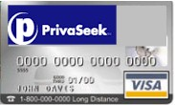
The Private Label, Affinity Card.
- A stored value (prepaid) Visa Card.
- Targeted at Gen Y teens.
- Maintains privacy, security, safety teens crave and parents demand.
- Ordered online at client's site, hosted by WallyCard.com.
- Funded online by parents or offline at retail stores with cash.
- Can be used anywhere where Visa is accepted (online or off) suitable for a teenager.

Online Teen Portals, E-tailer Incentives.
- Increases registered user base.
- Enables teen commerce to 93% of teens without credit cards.
- Increases revenue sharing from portal's e-commerce partners.
- 1:1 Marketing opportunities with rich, opt-in teen data:
- Demographic, psychographic self-reported data.
- Clickstream & navigational data.
- Transactional data from Visa card purchases, online & offline.
- Increases page views & site stickiness -- teen must check card balance at client-branded site.
- Develops brand loyalty -- real estate in the wallet.
- Enables viral marketing opportunities, affinity point programs, direct e-mail campaigns.
- Provides PrivaSeek's best-of-breed privacy technology:
- Registration System - scaled for 1,200 registrations per second.
- Persona Access Kit (PAK) - allows site to read opt-in, permissioned attributes of teens.
- Valet Toolbar - browser toolbar allows instant form fill at top 125 e-commerce sites.

Client Return on Investment (ROI).
- Client ROI in the range of 50%, breakeven at 20 months.
- 10¢ per card upon initial activation and recharge.
- Increased page views → higher advertising revenue.
- Increased revenue sharing.

Personalization & Privacy Technology

Unique Technology. The WallyCard solution offers robust and unique web-based technical capabilities. Through a strategic partnership with PrivaSeek, a leading manager and protector of consumer data on the Internet, WallyCard has acquired proven applications that enable permissioned-based sharing of consumer information. The Persona application seamlessly integrates with the consumer’s browser, similar to a digital wallet, and accumulates valuable data, which details the consumer’s web browsing habits. On an opt-in basis, consumers may choose to divulge a portion or all of the information in exchange for web site customization and in some instances for direct compensation. With WallyCard’s card registration interface, every Private-Label stored value Visa cardholder becomes a Persona.

- Persona™ This personal identification, profiling and preferencing solution is the first information control tool to help consumers automatically safeguard and gain value from their personal information when interacting with sites on the Web. Completely free to consumers, Persona helps Internet users regain control over their personal information by acting as a consumer driven information broker between the consumer and a Web site.

- PersonaValet™ The PersonaValet is a customized toolbar, which includes productivity tools to assist the consumer in optimizing their Persona data. Through the Valet, consumers can, among other things, automatically fill forms, track favorite sites, access bookmarks and manage information in their Persona. Businesses can use PersonaValet to guide consumers to relevant offers, effect real-time communication and retrieve a consumer's profile based on established permissions.

- Persona Profile Access Kit (PAK) The Persona PAK enables businesses to interact with consumers' Personas. PAK gives businesses the ability to individually communicate with every registered customer using only the information they have permission to access. PAK provides the data businesses need to deliver a personalized experience through customized content and sign-on recognition. The technology also helps businesses develop single-click shopping and manage passwords.

Benefits to Private Label Clients:
- Enables a closer customer relationship: You can create a more personalized advertising and web-shopping experience from your consumer's data profile.
- More efficient marketing communications: You can develop more targeted advertising and promotions based on the data collected.
- Access to rich data: WallyCard will create reports on a monthly basis which merge the browsing data with transactional data. The reports capture critical information on your consumers, giving you a better understanding of their buying habits.
- Reduce costs associated with managing and using consumer information within business processes.

Benefits to the Cardholder:
- Protects cardholder’s privacy online: Only information that is opted-into (permissioned based) by the cardholder is disclosed. Controls how much personal information is exchanged and how the information is used with your web site so, you maintain a good relationship with your customers.
- More personalization: A custom web page at the your site (hosted by WallyCard) can now be provided based on characteristics important and relevant to the cardholder.
- Cardholders will only be marketed to by merchants of interest.
- Manage the accuracy of personal information using convenient control tool.
- Receive personalized incentives and offerings from your business.
- Increase confidence in online activities.

The Teen Market
Macro View:
Demographic.
- 30 million U.S. teenagers, growing at twice population rate to 35 million teens by 2010.
- 72% of 13-18 year old teens use computers at home.
- 8.4 million teens actively use Internet, growing to 17.8 million by 2003.
- Generation Y teens born in the 1980s are the wealthiest teen generation in U.S. History.
Financial Standing.
- More than 20% of teenagers have checking accounts; 70% have savings accounts.
- 7% of high school students have a major credit card, compared to 55% of college students.
Spending Behavior.
- Teens spent $1.8 million online in 1998, $1.3 billion by 2002; 76% used a parent's credit card.
- Average teen shops 54 times per year, and spends $84 per week.
- Teens spent $143 billion at retail in 1998. $94 billion was their own money, $47 billion was “family money”.
- Teens in 1998 spent $35 billion on apparel, $22 billion for movies and music, and $6 billion on sporting goods.
Online Behavior.
- Teenage Boys currently buy CD's, video games and DVDs online.
- Teenage Girls currently buy CD's, clothing and accessories online.
- Why Buy More Online? 72% - Better Prices, 52% - If Parents Will Allow to Use Credit Card.
- Teens are only 2% of online buying population, but 8% of total Internet browser population.
- Nearly 50% of teens have purchased through mail order catalogs. Past catalog behavior demonstrated to be best predictor for conversion to online purchasing.

Micro View:
A Closer Look at Jill Teenager and her Friends.
- Jill plays team sports, is racially diverse, and loves to spend time and money shopping.
- She's popular among her small social group, and helps set trends.
- Jill cares about what she wears, how she looks, and what others think of her.
- Jill takes fashion cues from older brothers and sisters, popular music stars, and pro athletes.
- Jill wants to be spoken to directly, and treated like an adult.

Jill's Themes of Adolescence.
- Breaking Away - Desire for autonomy, Separating from parental structure, Resisting authority.
- Hanging Out - Defining oneself, Socialization, Confidence, Trust, Badges of Membership.
- Utopia Now - Personal Ideology, Taking Control.
- I, Me, Mine - Popularity, Narcissism/Self-obsession, Extreme Sense of Uniqueness.
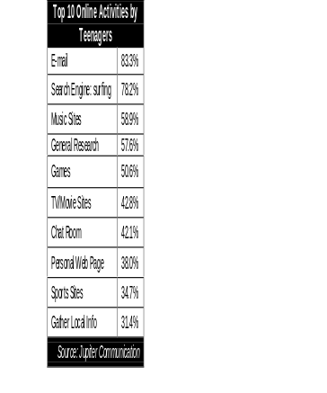

Competition -- Teen Payment Solutions
Visa-Branded Competitors:
Offer an embossed plastic card that can be used anywhere Visa is accepted. All require a parent’s credit card or checking account as a source of funds, and are only available online.

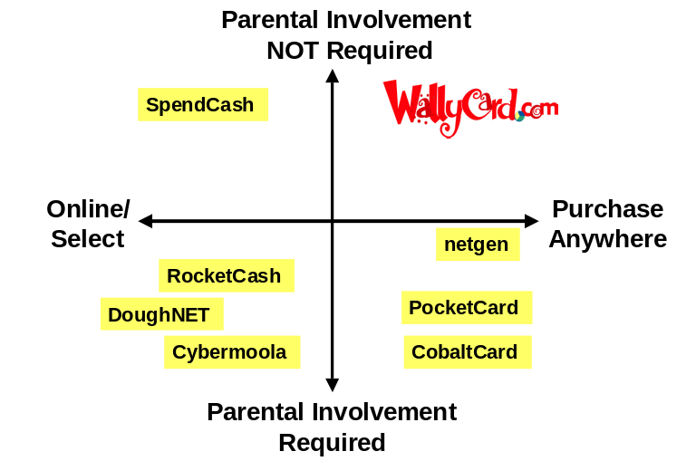CobaltCard
- Visa/MC branded card.
- Tied to parent’s bank account.
PocketCard
- Visa/MC branded card.
- Controlled by parents.
- $15-$20 activation fee.
CardEx.com, Universal Giftcard
- Visa/MC branded card.
- $6.95- $12.00 activation fee.
- Purchase with existing credit card.

Cybermoola.com  - Tied to parent's credit card or bank account.  - Accepted at 27 Merchant Sites.  - Seeded California Market with $2 million in free cards. | RocketCash Corp.  - Tied to parent's credit card or bank account.  - Accepted at Fogdog Sports, GamePro  Superstore, CDNow, Amazon.com.
DoughNet Inc.  - Tied to parent's credit card or bank account.  - Limited selection of merchants. | IcanBuy.com Inc.  - Tied to parent's credit card or bank account.  - Kids can give money to charity.

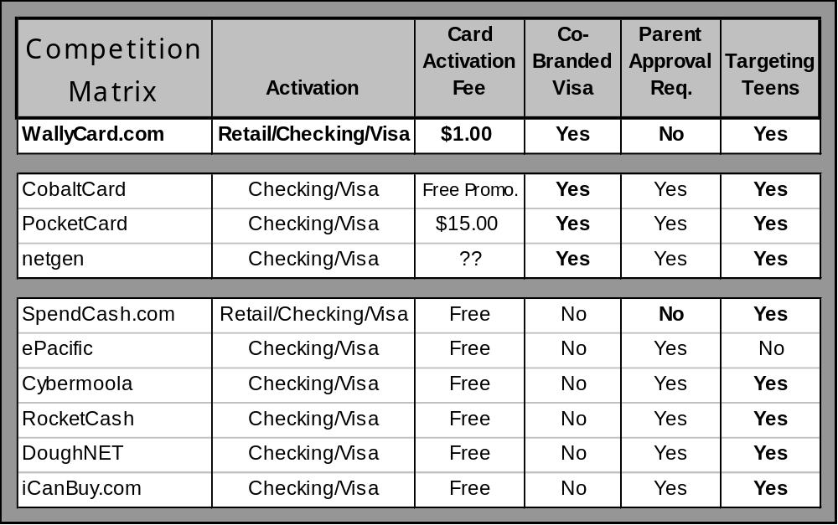
Proprietary e-currency
Private Label Visa Card
Visa Debit Card

How WallyCard Works

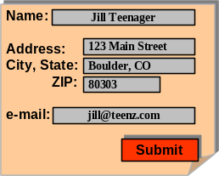


The Teen's Perspective.




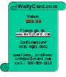

- Jill Teenager clicks from an online portal (i.e. Excite)
or calls 800# to register for a new Visa stored value card.
Verifone
- www.Excite.WallyCard.com – WallyCard hosts card registration site with Excite Logos and advertising.
- Jill gives her name, address, and email,
and selects a PIN# for ATM.

- An unactivated Visa card, embossed with Jill's name,
arrives via mail.

- Jill takes her Visa card to a participating retailer,
and hands the clerk $60 in cash.
- The clerk presses "[Prepaid]", "60.00", and swipes the card through the credit card reader.
- The credit card printer generates a receipt confirming the transaction amount of $60.00.
- Jill can now purchase anywhere Visa is accepted suitable for teens, online or off, and can use the card at an ATM.
The Merchant's Perspective.
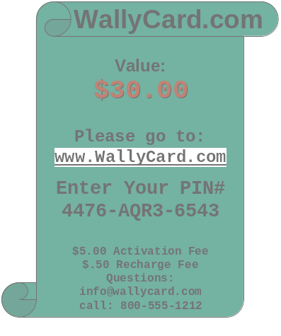




- WallyCard installs software onto Point of Sale (POS) terminal.
Modem
Account Database
EFT $$
Merchant's
Bank Account
+ commissions

- commissions
- Clerk accepts cash from teen, $60.00.
- Presses "Pre-Paid" Key, keys "$60.00", swipes card through credit card reader, "ENTER".
- POS Terminal dials into modem pool, sends Visa card # (BIN), Merchant ID# and transaction amount to WallyCard database for card activation.
- Two-part confirmation receipt printed; Top copy to teen, Merchant keeps bottom copy.
- WallyCard batch transfers funds from Merchant's account, less commissions for each transaction.

Distribution Channels
Three Primary Channels. The WallyCard will reach end-consumers in three ways: (1) from offerings on private label client sites for a site-branded stored value affinity card, (2) bundling the card with WAP enabled cellular phone sales and (3) promotional material at point of sale for a retail-branded store value affinity card.

(1) Private Label Client Sites.
The private label stored value affinity card: Jill Teenager sees a new link on her favorite Internet portal or e-tailing site: “Order a private label Prepaid Visa Card Now”.
- Jill registers for the card online at the client's site, e.g. www.Excite.com (hosted by WallyCard.com) and automatically become a registered user on Excite’s site.
- Jill activates the card at participating point of sale locations discussed in (3) below.

(2) Wireless Application Protocol (WAP) Providers.
With the purchase of a WAP enabled phone, Jill Teenager is automatically registered for a stored value private label Visa card. The WallyCard solution will allow prepaid cell phone providers a mechanism to receive payments from their customers on an ongoing basis.
- The card arrives via mail and is activated at participating POS locations discussed in (3) below.
- As part of WallyCard’s agreement with WAP Providers, the WallyCard stored value payment mechanism will be integrated into the functionality of the WAP enabled phone.
- Jill will now be able to make purchases with her WAP enabled phone up to the amount stored on their WAP provider private label Visa card.
- WallyCard collects another form of cardholder purchasing data, location-based purchasing along with clickstream, navigational, and transactional.

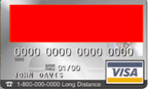

(3) Retail Point of Sale (POS).
The Prepaid Retail Visa Card: Jill Teenager sees promotional material at store, "Get Your Prepaid Visa Card Here".
- Jill registers for the card at the store by filling out a stamp addressed postcard or online at www.WallyCard.com. Jill would also be able to register over the phone or via fax.
- Jill activates the card at participating POS locations.

Value to Retailers:
- $4.50 per new retail card registered.
- 50¢ per card recharge/activation.
- No inventory or new hardware requirements.
- Increases foot traffic.
- High propensity for secondary high-margin purchases.
- Enables consumer loyalty rewards programs.
- Creates promotional incentive opportunities (e.g. special coupon offerings).
- Gain access to your customers’ information on a permissioned basis.

Seamless Technical Integration.
- WallyCard web interface integrates seamlessly into existing web sites in addition to having the ability to stand on its own, therefore, the client is not required to modify their web site.
- 3 minute POS installation by a WallyCard installation agent.
- No hardware requirements Uses existing Verifone and similar POS terminals.
- WallyCard installation agent installs software onto POS terminal: types in series of keystrokes, terminal dials 800#, downloads software.

Sales Funnel
Private Label Merchants.
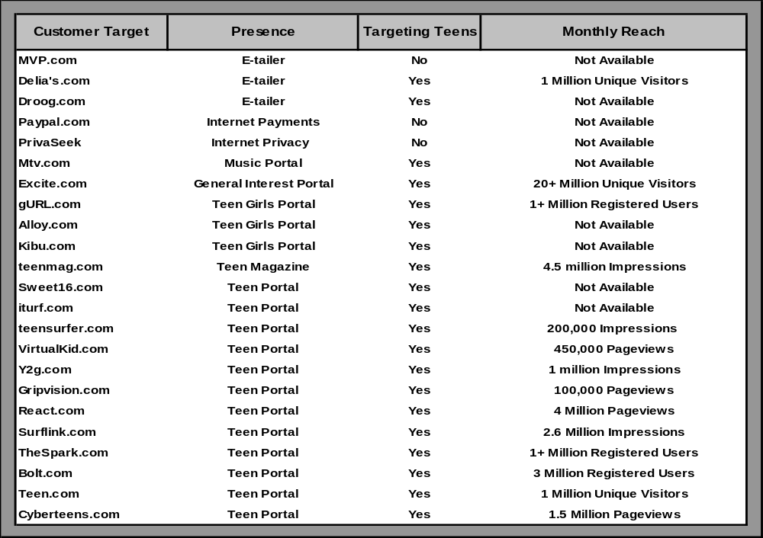
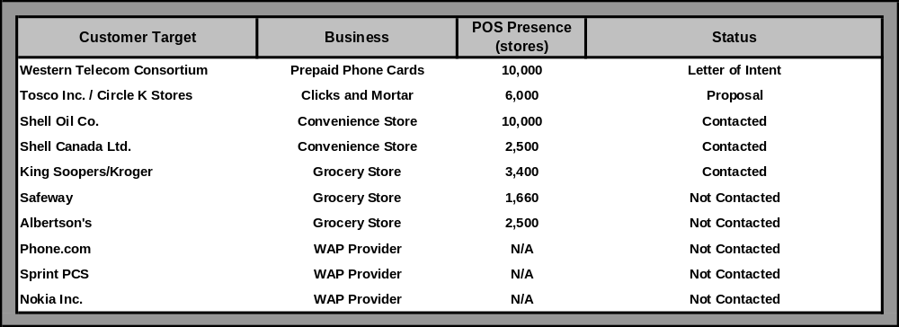
Distribution Channel Partners.

Revenue Model

Primary Sources of Revenue.
- Private Label Sales:
- Initial fee for web development, card design and initial card inventory.
- Monthly maintenance fees for ongoing customer service and access to rich transactional and navigational profiling data.

- Transaction Revenues on the sale, use and non-use of prepaid internet purchasing cards:
- Access fees paid by cardholder: $1.00 per activation and recharge of private label cards, $8.95 per activation of retail cards, $1.50 ATM fee.
- Access fees paid by private label customers: $1 upon registration and $1 upon initial activation.
- Merchant fees based on the volume of transactions conducted on the cards.
- Interest earned on unused card balance.
- Prepaid phone minutes: 18¢ per minute.

- Sale of Teenage Consumer Data:
- Aggregate data sales to targeted marketing and research firms (e.g. DoubleClick and Forrester Research).
- Revenue sharing from sites reading opt-in, permissioned attributes from cardholders.

- Credit Card Up-Sales
- Bounty fees paid by traditional credit card companies for the up-sale of stored value cardholders into credit cardholders ($30 per converted cardholder).

Primary Operating Expenses.
- Development Costs:
- Integrate banking systems, POS, PrivaSeek registration mechanism.
- Develop front-end, template-driven website for private label clients.

- Transaction Processing Costs:
- Distribution fees paid to POS partners (e.g. 50¢ per card activation/recharge).
- Transaction fees paid to banking and card processing partner (e.g. batch, authorization).

- Customer Service Costs:
- Telephone call center provided to private label clients as part of monthly maintenance fee.
(99¢ per minute).

- Salaries and Benefits:
- Experienced executive management.
- Systems development and other technical personnel.
- Sales force to obtain private label clients.

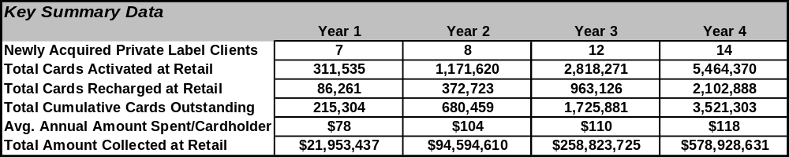

Revenue Model

Annual Projected Financials.
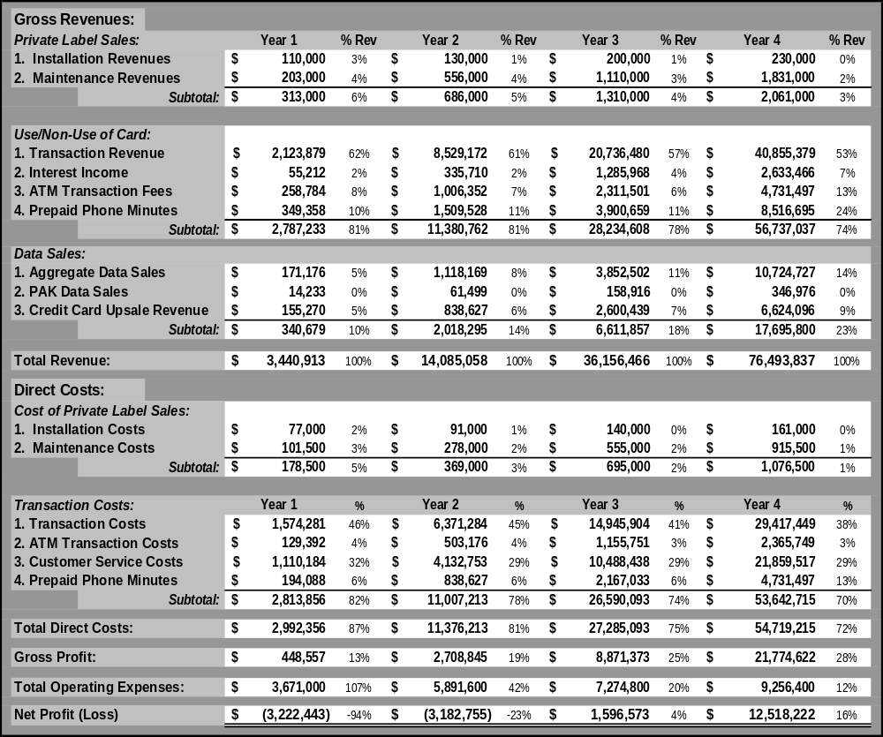

Offering

Funding Requirements and Use of Proceeds.

Series A. Currently seeking $3 million.
- Use of Proceeds:
- Integrate banking systems, POS, PrivaSeek registration mechanism.
- Develop front-end, template-driven website for private label clients.
- Beta test technology.
- Roll-out private label offerings.
- Recruit senior management.
- Sales force to obtain private label clients
Series B. Future $6 million round.
- Use of Proceeds:
- Ongoing systems development.
- Ramp up technical, sales and management staffing.
- Private label promotional program.

Investor Profile.
- Experience and contacts in the e-commerce, retailing and banking space.
- Assistance in recruiting management with substantial experience in the e-commerce, banking and retail space.

Previous Financing.
- $45,000 financing to date, consisting of cash and services awarded for winning CU Boulder Bank One Business Plan competition.

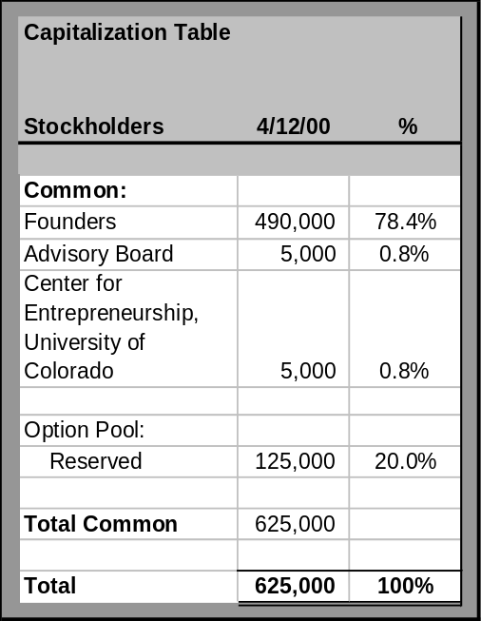

Competitive Advantage

Transparent to merchants
- Can be used anywhere Visa is accepted (suitable for a teenager).

Stored value solution:
- No bank account needed.
- No parental involvement required.

PrivaSeek's best-of-breed privacy protection.

Scalable solution for retail partners:
- No inventory required.
- No additional hardware at retail.

Rich complete profiling of consumer information, opt-in data from:
- Transaction data from both online and brick & mortar.
- Clickstream and navigational data

Established partnerships in place:
- Stored Value Card: Prepaid Technologies
- Card Issuing Bank: Columbus Bank & Trust and Visa
- Payment Processor: Total System (TSYS)
- Privacy & Registration: PrivaSeek
- Retail Sales Channel: Western Telecom

Private label strategy leverages existing customer base of both online portals and brick and mortar retailers.

Management Team

Nathan Foran, President
Nathan Foran has six years of entrepreneurial experience including founding Food For Thought and 20_Something, Inc. Most recently, Foran worked in the venture capital industry for OffRoad Capital, a Silicon Valley venture capital firm, and for Stolberg Equity Partners based in Denver Colorado. At OffRoad Capital Foran structured the company's first successful $6,000,000 private placement as part of a three-person team and for Stolberg Equity Partners he contributed to closing a $5,000,000 private financing. Earlier in Foran's career, as the CEO of 20_Something, Inc, Foran focused on expanding the company's product offerings and gaining market presence, successfully establishing distribution channels providing products to more than 125 retail locations in twelve cities. Foran also has worked as a finance and marketing consultant for software companies such as Digital Pictures, Macromedia and Oceania. Foran received an MBA degree with honors, Beta Gamma Sigma, from the University of Colorado with a double major in Entrepreneurship and Technology & Innovation Management.

Jeff Finkelstein, Chief Information Officer
Jeff Finkelstein recently worked at PrivaSeek to develop a process to verify a web site’s online information practices meet privacy guidelines and W3C P3P protocols as well as helped to create a database-driven direct email product that rewards consumers for sharing personal information. Finkelstein has developed web sites and Internet strategies on a project basis to companies in the Boulder area while serving as the CEO for Entrepreneurial Solutions, LLC. Client projects included a market positioning study of web-enabled Electronic Data Interchange opportunities for netDelivery, an Electronic Billing, Payment & Presentment company, and a strategic analysis of the Customer Relationship Management space for MessageMedia. Finkelstein graduated from University of Michigan, and holds an MBA in Entrepreneurship and Technology & Innovation Management from the University of Colorado at Boulder.

Lisa M. Ferrari, Chief Marketing Officer
Lisa Ferrari brings seven years of integrated marketing communications experience to the WallyCard team. Ferrari has worked with Juice Branding Inc., a Denver based brand marketing consulting firm doing extensive consumer research. Ferrari also worked as an Associate Brand Manager for Reebok International, Ltd., and was responsible for the development of marketing initiatives for the Reebok Classic category. Ferrari’s target consumers were 12-17 urban, trend-setting youth. Ferrari traveled the country doing primary research on her consumer and established targeted marketing campaigns towards these teens. Prior to Reebok, Ferrari worked at CPC Inc., a Boston based agency with a niche in diversity marketing and cultural communications. Ferrari earned her Bachelor of Arts degree with honors in Communications/Marketing from Boston College and graduated with an MBA in Marketing and Entrepreneurship from the University of Colorado.

Andrew Wilson, CPA, Chief Financial Officer
Andrew Wilson worked for three years in the Assurance and Advisory Business Services division of Ernst & Young LLP in Dallas, obtaining his CPA certification and working with a large variety of clientele, including Southwestern Bell Wireless and A.H. Belo Corporation. Wilson also worked in Ernst & Young's Entrepreneurial Services group, facilitating private equity transactions and helping position clients for future initial public offerings of stock. Wilson has worked at IBM in New York and in the portfolio management area of Salomon Smith Barney. Recently, Wilson was a summer associate at Wolf Ventures, a $40 million venture capital fund in Denver, Colorado. At Wolf Ventures, Andrew evaluated numerous business plans, performed due diligence on potential investments, and worked closely with the local Denver-Boulder entrepreneurial community. Wilson graduated with honors from Texas A&M University with a bachelors degree in accounting and holds an MBA, with honors, in Finance and Entrepreneurship from the University of Colorado.

U.S. Census Bureau; Chicago Tribune, 3/5/2000.
Jupiter Research.
Source 2000, Feb. 1999.
April 1999 Food Processing.
Youth & Money 1999.
New York Times.
Teenage Research Unlimited 1999.
Teenage Research Unlimited 1999.
TM January 2000.
Iconocast March 2000.
The Geppetto Group 1998.

