Twelve Steps to a Successful Business Plan
Step 5: Begin Development Plan

You begin work on the Development Plan section of your business plan in Step 5:

In your Development Plan, you will outline how you intend to ramp-up your business. This section is often woefully under-developed in many business plans. Assuming you have a dynamic marketing plan and customers do indeed come flocking for your product or service, you must be able to deliver it to them. The Development section is a road map of how you are going to get from where you are now to where you want to be in the future. If you are starting a business, what are all of the steps that you need to accomplish to get the business up and running? If you are expanding a business, what do you need to do to make it grow? These steps can be as routine as securing retail space, or as critical as applying for and getting a patent on key technology. Don't go into too much detail here. For example, the need to get business cards printed probably does not belong in a development plan (although you might include it in a detailed checklist in the appendices). Use your judgment.

The first task in preparing your Development Plan is to create a Development Timeline in which you plan for a schedule for business development.
Also in Step 5, you will work on the Ongoing Operations subsection of your Operations Plan. In this subsection, you will describe and summarize all of the value adding activities that you will undertake in your business.
Within your Marketing Plan, you will address your Pricing Strategy and Distribution Strategy.
Finally, you will write a first draft of the important Management Team section of your plan in which you present your management team and the organization of the business.

Development Plan
Development Timeline

What is the timetable for launching our company and our products? (Consider adding a chart or table here?) Go out as far into the future as you have plans.

A useful tool to formulate and illustrate a development timeline is a Gantt Chart as illustrated here:

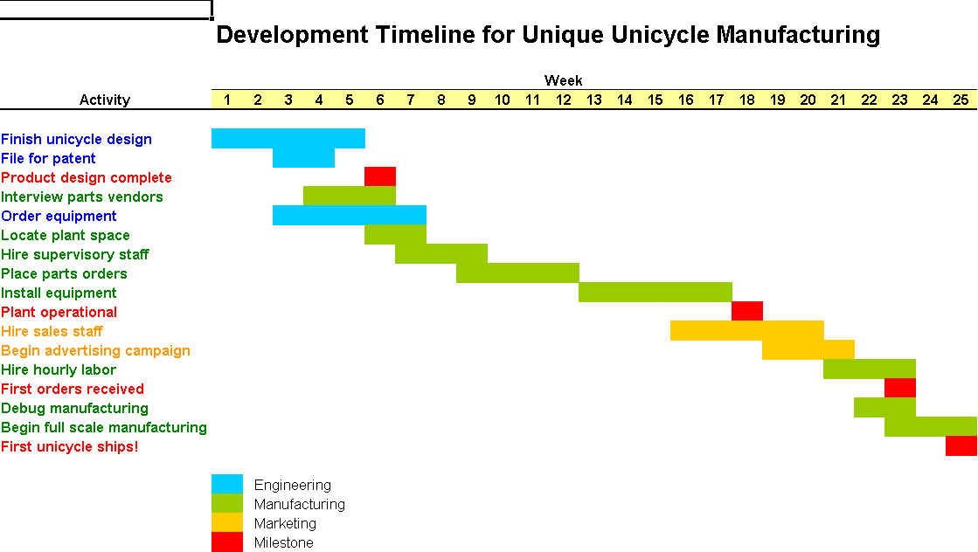

Marketing Plan

Pricing Strategy

Explain your pricing strategy and why it will be effective with your target customer in your marketplace.
- What is our pricing strategy? Why?
- How does our pricing strategy compare with our competition?
- What evidence do we have that our target market will accept our price?

Distribution Strategy

Describe your distribution strategy and explain why it is the best for your marketplace.
- How will we distribute our product or service?
- What distribution channels will we use? Why?
- How will we gain access to these channels?

Operations Plan
Ongoing Operations

The details of this section will vary widely from business to business. The purpose of this section is to describe your ongoing operations how they support the requirements of the marketplace. Include detail in an appendix, as necessary. As appropriate, consider issues such as the following:
- How will your company operate on an ongoing basis?
- Where we locate our facilities?
- What are our hours of operation?
- What kind of equipment will we use?
- Who will we employ and how will we train them?

Management Team

Venture capitalists often assert that there are three attributes important for a successful start-up business: management, management, and management. Many venture capitalist claim they will invest in a strong management team with a mediocre idea, but will decline to fund a weak management team with a great idea. The purpose of the Management section therefore is to convince the reader that you have a great management team to complement a great business concept. This is not the place for modesty or self-depreciation. Be honest, but highlight your accomplishments and your capabilities while mitigating any obvious shortcomings or weaknesses. For example, if you are young and inexperienced, accentuate your energy, capacity for hard work, and willingness to learn, while downplaying your lack of experience. When readers are finished with this section, you want them to be confident that your venture is in good hands and will be competently managed -- by you!

Company Organization

Describe how your company will be organized.

How will we be organized? What does our organization chart look like?

What is the ownership structure of our company?

Will we have a board of directors? Who will be on it? What will be their role?

Management Team

Describe the founders and principal managers who will run your firm.

Who are the key managers? (Include resumes in the Appendix)

What will be their duties and responsibilities?

What unique skills do they bring to the venture?

How will they be compensated?

What additions to the management team do we plan? When?

Action Items

- Complete a development timeline illustrating the important milestones and events in your business rollout.
- Write one to three paragraphs describing your timeline and rollout strategy.

Development Plan
- Development Strategy
- Development Timeline
- Development Expenses

- Complete drafts of you’re the pricing and distribution strategies for your product:

Marketing Strategy
- Target Market
- Product/Service Strategy
- Pricing Strategy
- Distribution Strategy
- Advertising and Promotion Strategy
- Sales Strategy
- Marketing and Sales Forecasts

- Write a one to three paragraph description of your ongoing operations:
Operations Plan
- Operations Strategy
- Scope of Operations
- Ongoing Operations
- Operating Costs

- Complete the first two parts of the management section of your plan. Collect personal resumes of founders and key managers to include in appendices.

Management Team

Company Organization
- Management Team
- Administrative Expenses

