ACCT 4540/5540: Accounting information systems
December 8, 2010

Schryver Medical
Mobile X-Ray Service Provider
Kathleen McBride kathleen.mcbride@colorado.edu (720)252-4879
Adam Wolf adam.wolf@colorado.edu (847)528-7734
Michael DeWitt Michael.dewitt@colorado.edu (720)878-5791

TABLE OF CONTENTS

Executive Summary 3
Industry Overview 4

Schryver Medical 5
Information Technology at Schryver Medical 5
Business Objectives 7
IT Objectives 11
IT Strategy 12
IT Policies and Procedures 13

Mobile X-Ray Process 14
Process Objectives 14
Key Performance Indicators 17
Process Explained 19
As-Is Process Map 22

Enterprise Risk Management 23
Internal Environment 23
Objective Setting 24
Event Identification 24
Risk Assessment 27
Risk Response & Control Activities 32
Information & Communication 39
Monitoring 40

Data Modeling, Query, and Business Report 41
Database vs. Master File System 44
Disaster Recovery Plan 45

New Mobile X-Ray Process 47
New Process Map 47
Process Explained 48
Benefits of New Process 49
New KPI’s 51

Conclusion 52

EXECUTIVE SUMMARY

Schryver Medical specializes in providing mobile x-ray services to nursing homes and their patients as well as other ancillary services. This service attempts to provide the highest quality image, reduced turnaround times, and the ability to view images on-site and on-line. The current system exhibits control issues including insecure spreadsheets, miscommunication, and confidentiality concerns. It is essential that these control issues be fixed and aligned with Schryver’s business objectives.

The current system suffers from insecure communication and storage techniques between dispatch, x-ray technicians, radiology, and billing departments. The current process has been mapped and redesigned to visually recognize opportunities to optimize efficiency and reduce error. Key performance indicators (KPI’s) have also been established to measure whether or not Schryver is achieving its business objectives. Internal and external risks have been identified and categorized according to our risk appetite of 42 and the negative implications these risks have on the business objectives. We suggested controls to be put in place to reduce or eliminate identified risks. One major concern that is addressed is fulfilling HIPAA requirements concerning the storage and accessibility of confidential patient information.

Schryver Medical offers a necessary service but utilizes insufficient and flawed data entry, dispatch, and storage systems. In order to increase efficiency and reduce error to serve the patients and nursing homes to the best of the firm’s ability, Schryver must redesign its process and incorporate the proper controls. These controls must ensure accurate data, security, and patient confidentiality. The implementation of a web based system and integrated database that allows communication between dispatch, the x-ray technician, nursing home, and billing department would be a significant improvement from the current process.

INDUSTRY OVERVIEW

The process that we chose to analyze is the mobile x-ray industry. The history of the mobile x-ray industry begins with the invention of the first medical x-ray machine by German-born William Roentgen in 1895. However, it was the American mechanical engineer Fredrick Jones who invented the first portable x-ray machine in 1919. Since that time, others have taken his invention and produced versions of their own. These first portable x-ray systems were burdened with the same problems of using toxic chemicals and the danger of radiation to the patient as the non-portable x-ray machines. In the 1970’s, Godfrey Housfield invented the first CT scanner, which began the revolution in digital imaging techniques. This technology allowed for high quality images with a lower dose of radiation. There are many other benefits to the digital image as it can be magnified, flipped, and measured. These images can be sent to the radiologist within minutes and can be stored for years. The combination of the portable x-ray system and the digital imaging techniques lead to the explosion of the mobile x-ray industry.

The goal of the mobile x-ray industry is to provide a cost effective, convenient, quality service to the community. It provides reliable x-ray diagnostic units to ambulatory and non-ambulatory patients. This service saves the patient the inconvenience of traveling to the hospital or clinic, and also saves on the cost of that medical service. According to the House Committee on Small Business report, 2002, “the portable x-ray industry saves Medicare nearly $2.5 billion annually on ambulance and hospital fees.” Additional benefits to society are created by participating in health fairs and being involved at senior centers. The mobile x-ray industry provides a valuable service to the community through technologically advanced equipment and qualified technicians. Overall, our analysis of the mobile x-ray industry proved to be an interesting case study because the process reflects the issues that arise when a process becomes too habitual and technologically outdated. We accredit Schryver Medical for the majority of our research and findings.

SCHRYVER MEDICAL

Schryver Medical was established in 1986 as a mobile x-ray service provider provider of mobile x-ray service in Colorado. The company’s revenue was $8,500,000 and $7,950,000 for years ending December 31, 2008 and 2009, respectively. Market share continues to increase and stands at 76% in Colorado. The company attributes its success to a continued focus on improving accuracy and timeliness of x-rays. The company owner, and 100% stockholder, is involved with both sales and operations and continually seeks input on how to improve the business from both clients and employees. The owner and V.P. of sales and operations manage the company’s day-to-day operations. A quality of assurance committee and customer advisory board provides feedback on the performance of the company. The culture is one of openness and seeks input from internal and external customers in an effort to continually improve.

Information Technology at Schryver Medical

Information technology is the weakest functional area at Schryver Medical. Historically, the IT department has been run by two individuals with an annual budget of 0.5% of revenues or approximately $425,000. The demands on the technology group increased dramatically in 2004 when the company made a $1,000,000 investment in mobile digitized technology and a pictorial archive system, PACS. Previously, the equipment consisted of film technology. This costly and outdated technology involved using x-ray film that was developed in vans that had been converted into dark rooms. Film from past x-rays were stored in a 1,200 square foot disorganized and unsecure filing room. When nursing homes requested old x-ray films, x-ray technicians were reluctant to drive to the main office and sift through the filing room. This became a major customer service issue since it often took several days to respond to film requests. However, with the new PAC system, patient x-rays can now be readily accessed by internal and external users with the proper identification from the web based system. Internal users with access to x-rays include IT and the billing group; external users with access include radiologists, nursing homes, and nurses.

Converting the company to full digital x-ray technology proved to be a smart business decision because it shortened turn-around times for x-rays, eliminated timely film development, and created an overall more efficient process. The new technology created an increased demand for the IT Department because they were involved in the purchase, implementation, training, and continued maintenance of the PAC system. The PAC system demands a great deal of time and resources to keep it up and running. Unfortunately, no technological improvements were made to the order intake, dispatch, or billing systems.
While the goal of the company was to continue to improve technology in the x-ray reading area, improving intake and billing was unrealistic with only two people in the IT department and a limited budget. Currently, orders are placed by a nurse over the phone and are stored at Schryver in excel by date. This is an inefficient manner of storing the data because an employee can only access past transactions by looking them up by date. Looking up x-rays for individual patients would provide much more useful information than searching by date. While intake uses excel, the billing department uses Medisoft, an insurance billing software. Billing re-enters the intake information from excel into Medisoft which then gets sent to the third party insurance company. The x-ray reading, intake, and billing areas function under different systems that do not talk to one another.

SCHRYVER MEDICAL’S BUSINESS OBJECTIVES

Schryver Medical’s business objectives are as follows:
- To be the number one provider in Colorado of quality x-ray and diagnostic services to patients residing in nursing homes.
- To provide nursing home patients mobile x-ray services as an adequate alternative to a costly and stressful emergency room visit.
- To consistently provide quality x-ray services with timeliness and accuracy in order to diagnosis illnesses or injuries.
- To be financially viable by collecting 97% of billed revenue to third party insurance companies.
- To increase revenues by 10% per year.

Primary Objective: To be the number one provider in Colorado of quality x-ray and diagnostic services to patients residing in nursing homes.

As mentioned previously, Schryver is the leading provider of mobile x-ray services in Colorado with a market share of 76%. With over two decades of experience, Schryver is a name customers know they can rely on. However, this does not mean the company can be complacent and simply allow things to continue to operate the way they always have. The current process allows too many people access to private information and it stores data in a way that makes it very difficult to look up past orders. Many components within the process are flawed, mainly due to being outdated and inefficient. In order to continue to be the leading competitor, Schryver must adapt its system to become more efficient and have better internal controls. Failure to fix internal control issues could result in identity theft leading to lawsuits and possibly the end of the company.

Primary Objective: To provide nursing home patients mobile x-ray services as an adequate alternative to a costly and stressful emergency room visit.
There are many reasons why transporting a patient from a nursing home to a hospital is not as desirable as having the x-ray come to the nursing home. Nursing home patients are elderly and many cannot be moved around easily. A patient may be in a wheelchair, have a walker, or be bed-ridden. Employees would be required to transport the patient to the hospital and would have to stay there while the patient received medical attention. Taking the patient out of the nursing home creates a liability for the home and it would be a waste of money to pay an employee of the nursing home to sit at the hospital with a single patient. Calling an ambulance to transport a patient to the hospital is costly and the nursing home still has the extra liability of the patient not being at the home. Having the x-ray come to the nursing home allows employees to continue with their regular work tasks. Mobile x-rays are what makes Schryver’s service unique and needs to continue to be desirable in order to avoid being eliminated altogether.

Secondary Objective: To consistently provide quality x-ray services with timeliness and accuracy in order to diagnosis illnesses or injuries.
If a patient is in need of an x-ray it is imperative for that to happen in a timely manner. Keeping a patient waiting in pain is uncomfortable for him or her and bad for business for Schryver. Getting the x-ray to a radiologist for proper diagnosis and then getting that information back to the patient is the most important part of the service Schryver provides. The convenience factor of having the x-ray brought to the patient is worthless if the x-ray cannot be read or the person reading it is unqualified. The image generated by the x-ray machine must be accurately transmitted electronically to a radiologist. Failing to achieve this goal could result in fines or worse yet, closing of the business.

Secondary Objective: To be financially viable by collecting 97% of billed revenue to third party insurance companies.
The costs Schryver incurs for an x-ray service are covered by the patient’s insurance company or Medicare. The cost of each service is extensive and not recovering payment has significant consequences. If the billing department sends the incorrect information to the insurance company, the nursing home becomes responsible for covering the costs. Naturally, the nursing home does not want to have to pay, and incorrectly assigning costs could tarnish Schryver’s customer relations. In addition, nursing homes are more likely to avoid payment than insurance companies.

Secondary Objective: To increase revenues by 10% per year.

Keeping the customers Schryver already has is important for maintaining the company’s reputation as the leading service provider in the area. Losing a customer to a competitor means less revenue. Since the number of orders being placed per nursing home is not expected to drastically change, additional revenues are going to come from getting more nursing homes to be customers. The region in which Schryver operates has a limited number of potential clients. Schryver has to sell the benefits of its service so the potential customer can see the cost savings and convenience factor the company can provide.

SCHRYVER MEDICAL’S CURRENT GOVERNANCE

Strong IT governance should promote the alignment of information technology and business objectives, serving as a critical success factor for organizations. We will look to Schryver Medical’s IT strategy, enforcement, and structure in relation to the overall business objectives, legal regulations, and stakeholders.

IT Objectives
Schryver Medical categorizes its IT objectives as either immediate, less than one year, or intermediate, more than one year. Schryver Medical’s immediate IT objectives are as follows:
- 99% of uptime for x-ray (PACS), billing (Medisoft), and intake systems (excel).
- Replace six work systems that have reached the four-year life cycle.
- Audit x-ray PAC system’s compliance with Health Insurance Portability and Accountability Act (HIPAA).
- Create a business continuity and disaster recovery plan.
- Train technicians on troubleshooting and fixing equipment problems on the field to decrease reliance on the IT department.
- Train technicians on proper routine maintenance to ensure longevity of equipment and avoid costly repairs.
Schryver Medical’s intermediate IT objectives are as follows:
- Establish an enterprise system that would integrate intake and billing.
- Establish an IT training program for customers, specifically nurses, to increase ease of use with the systems.
- Enhance disaster recovery plan by including offsite storage of data.
- Develop enterprise systems that would create efficiencies in billing, intake, and dispatch to grow the business without additional staff.

IT Strategy
The structure of Schrvyer’s IT Department consists of the Vice President of IT and his subordinate, the IT Specialist. Together they are responsible for contributing to and achieving IT objectives. Operational management, including dispatch, x-ray technician, and billing, communicate their IT needs at an annual business strategy meeting and quarterly updates. The IT department and executive management evaluate the needs presented by operational managers based on necessity, budget concerns, and alignment with business objectives. These needs are then translated into the IT objectives. The clients (external stakeholders) play a roll in IT strategy through an annual customer-advising meeting as well. In addition, quality assurance surveys are compiled and analyzed. IT solutions to customer concerns and needs are assessed and help shape the IT objectives listed above. For example, Schryver set an IT goal of replacing work systems for the billing department after the billing manager presented this need at the annual strategy meeting. This was a high need venture that fit within the budget and was therefore added as an immediate objective. Also, the customer Christian Living Communities voiced its concern that the PAC system was complicated and not user friendly. Executive management evaluated this need as a medium level of necessity that would promote the business objective of providing an adequate alternative to in-hospital visits. They translated this into the intermediate objective of establishing a customer-training program.

The healthcare industry must function under strict and changing government regulations. Schryver’s IT helps comply with privacy regulations. In accordance with HIPAA, patient information must be kept from any outsider (any individual where patient information is not pertinent to his or her job). One of IT’s main responsibilities is to keep this data secure through the use of usernames and passwords which grant an employee specific data access.

IT risks are monitored through the use of KPI’s discussed below. Otherwise, at Schryver, risk falls outside of the scope of the IT department and is often overlooked. A formal risk understanding and evaluation is a weakness that will be addressed later.

IT Policies and Procedures
Schryver Medical has a formal IT training process that has room for improvement. Upon hiring, employees are trained in classrooms and through formal and informal mentorships about software usage. Little attention is given to retraining the employees when systems have undergone changes. The importance of data privacy is not communicated to employees below middle management. There is also no company literature discussing IT policies. Suggestions on IT policy and procedures will be discussed in greater depth below.

MOBILE X-RAY PROCESS OVERVIEW
The scope of the mobile x-ray process is from the time the order is placed by the nursing home to when the nursing home receives the radiologist’s report. The process begins when a nursing home places an order with an intake employee. The intake employee enters pertinent information into an excel file which is sent to dispatch. Dispatch assigns an x-ray technician to go to the nursing home and take the x-ray. The technician completes the x-ray service and uses the PAC system to send the x-ray to the radiologist and Schryver for record keeping. The radiologist records the reading, which is sent to the nursing home and intake. This completes the process.

MOBILE X-RAY PROCESS OBJECTIVES
Schryver Medical’s mobile x-ray objectives are as follows:
- To record accurate information about the service to be provided.
- To notify and deploy x-ray technicians in the most effective and efficient manner based on designated location.
- To ensure the patient and customer is cared for to the highest of standards.
- To make certain the x-ray image is readable before being sent to the radiologist.
- To provide the x-ray and a diagnosis within six hours of receiving the order.

Primary Objective: To record accurate information about the service to be provided.
When the nursing home places an order, the person receiving the order at Schryver must accurately record the information being told to them by the nursing home. This information includes the name of the patient, location of the nursing home, patient room number, and symptoms the patient is experiencing. Accurately recording this information is required in order to determine what part of the body an x-ray is needed for. Incorrectly recording this information could lead to unnecessary x-rays being taken on parts of the body that are not experiencing any problems.

Primary Objective: To notify and deploy x-ray technicians in the most effective and efficient manner based on designated location.

X-ray technicians are located throughout the region Schryver services. Depending on which nursing home places an order, the technician closest to that home should be dispatched in order to reach the destination in the shortest amount of time. This also saves Schryver the cost of gas that would be used having technicians driving all over Colorado. This helps ensure that the technician arrives at the home with enough time to complete the service within the goal of six hours.

Primary Objective: To ensure the patient and customer is cared for to the highest of standards.
Conducting the x-ray in a professional manner where the patient feels comfortable is of the utmost importance for Schryver. Additionally, it is important for the technicians to have a good working relationship with the nursing home. If the nursing home is unhappy with the technician, they may be hesitant to call Schryver for its services again. Nursing home reviews of each technician would be a way for Schryver to ensure that its employees are all conducting business in a way that shines a positive light on the company.

Secondary Objective: To make certain the x-ray image is readable before being sent to the radiologist.
The digitized image of the x-ray that is sent to the radiologist must be readable in order for the radiologist to accurately assess the patient’s ailment. If the radiologist cannot clearly see the x-ray there is an unacceptably high level of risk that the radiologist will misinterpret the x-ray. Having to retake the x-ray at the nursing home and/or resend the image to the radiologist is a waste of time and resources.

Secondary Objective: To provide the x-ray and a diagnosis within six hours of receiving the order.

As mentioned previously, keeping the patient waiting is an inconvenience to him or her and it reflects poorly on Schryver’s reliability. Having the x-ray come to the nursing home is a convenience that the customer is willing to pay for, but it also saves money. Since the mobile x-ray costs are less than that of a hospital visit, the nursing homes would prefer to use a mobile provider. However, if the time between when the order is placed and when the service is performed begins to take too long, then customers become unhappy and could switch to a competitor. Schryver will become obsolete if the competition can perform the same services in less time.

MOBILE X-RAY KEY PERFORMANCE INDICATORS
It is essential that a company assigns and measures certain targets. This communicates to employees what aspects of the process are important and allows management to track the process’s performance. KPI’s are a way to achieve business objectives and control a process. Schryver Medical’s mobile x-ray KPIs are as follows:
- Intake team to answer phone within four rings.

- Dispatch technician within 30 minutes of intake.

- X-Ray technician arrive at nursing home within two hours of dispatch.

- Provide results to nursing home within four hours for STAT (urgent) and six hours for routine x-rays.

- Strive for 100% accuracy in all X-Ray readings.

- Strive to bill 100% of all orders to the third party insurance company.

- Collect 97% of all third party billed revenue.

- Maintain 100% of client base.

Answer the intake phone within four rings.
High quality customer care is a process objective. A primary aspect of customer service is providing a service that is readily available and easy to use. Measuring the average time it takes to respond to a customer’s phone order ensures employees treat customers as a top priority.
Dispatch technician within 30 minutes of intake.
Measuring a dispatch time KPI ensures that the dispatch employee strategically assigns a technician to a nursing home based on location, achieving the primary process objective of effectively and efficiently assigning technicians to orders.

X-Ray technician arrive at nursing home within two hours of dispatch.
Measuring technician to nursing home time makes certain that technicians use their time efficiently. In addition this measure strives to maintain the primary goal of customer and patient satisfaction because it tracks the timeliness of the service.

Provide results to nursing home within four hours for STAT and six hours for routine x-rays.
This coincides with the objective of returning results to the nursing home within six hours. It places a more stringent time requirement on STAT, urgent, orders so that patient care is maintained.

Strive for 100% accuracy in all X-Ray readings.
The X-Ray reading must be accurate every time to achieve patient care. This measure makes employees recognize the seriousness of a patient’s health; veering from this objective puts ones job at risk.

Strive to bill 100% of all orders to the third party insurance company; Collect 97% of all third party billed revenue.
If an order is inaccurately billed to a patient’s third party insurance, revenue will not be collected, sacrificing revenue objectives and the ability to be financially viable.

Maintain 100% of client base.
This KPI looks at the success of the process as a whole. It challenges all employees to maintain customer relationships and has management discover why a customer is lost and how to make changes.

MOBILE X-RAY PROCESS EXPLAINED
The process used to place and record the mobile x-ray orders begins at the nursing home. The nursing home will call Schryver and be connected to an intake employee to place the order. The intake personnel will request the nurse’s name, nursing home name, patient name, patient social security number, patient’s insurance provider, type of x-ray to be performed, and symptoms the patient is experiencing. This information is communicated verbally over the phone and entered into an excel spreadsheet by the intake employee (Exhibit 1). The order is processed and reread to the nursing home for validation. If all the information is correct, the data is now ready for the dispatch employee. The intake personnel uses an open excel spreadsheet that the dispatcher has access to. When the dispatcher sees that an order has been placed, he or she can notify a technician in the field.

The dispatch employee will assign the x-ray service to an x-ray technician. X-ray technicians are in designated zones with x-ray equipment that is located in vans. The dispatch employee contacts the x-ray technician who is located in the assigned zone. The assigned technician’s name, time of dispatch, time dispatch is confirmed by the technician, and time the x-ray is completed by the technician are all added by the dispatcher into the spreadsheet as the technician completes each of these steps. The x-ray technician receives the x-ray assignment via text message. The technician sends a text back to dispatch to confirm the requested x-ray services. The technician sends a text to the dispatch employee once the service is complete. The x-ray that the technician took is digitized and stored in the PAC system and sent to a radiologist. The x-ray is viewed by the radiologist on a high resolution computer screen, where it is interpreted. The diagnosis is typed and then faxed to the nursing home as well as back to the dispatch personnel. Upon receiving the reading, the dispatch personnel closes the order within the excel file (Exhibit 2). Billing will then input the information from the original order excel file into the Medisoft billing system (Exhibit 3). This is sent to the insurance company and payment is later collected.

Exhibit 1
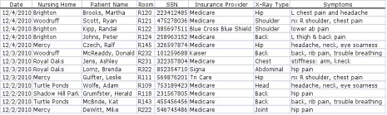

Exhibit 2
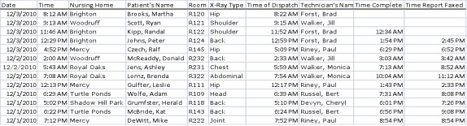

Exhibit 3
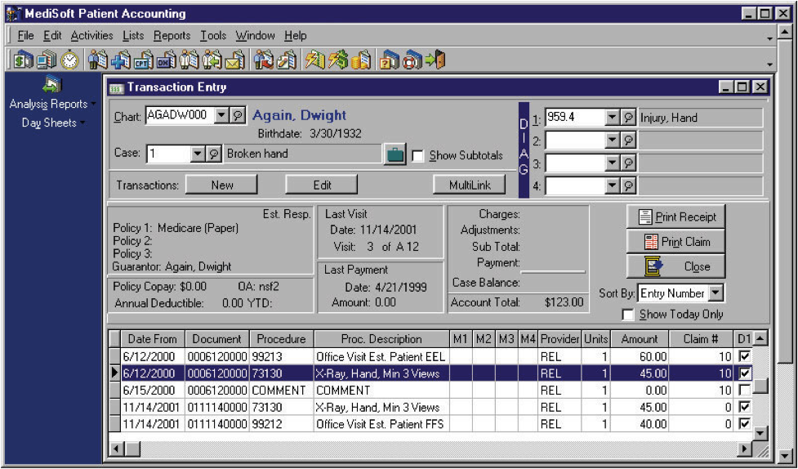
CURRENT PROCESS MAP
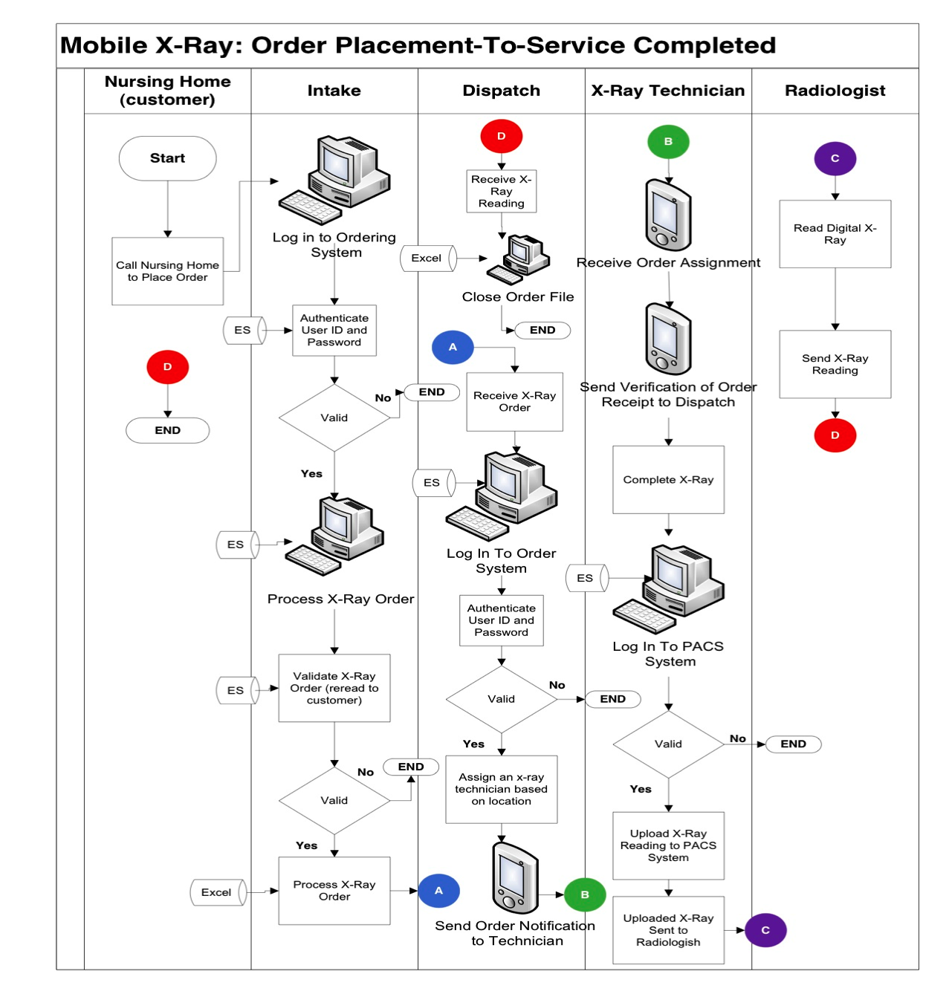
PROCESS SUGGESTIONS:
SUGGESTION: ENTERPRISE RISK MANAGEMENT
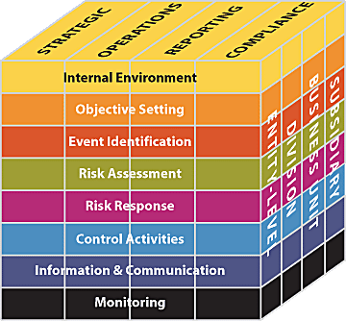
It is surprising that Schryver has no formal risk policy despite being a fairly large, well-run and successful company. In fact, risk is not incorporated into Schrvyer’s strategy. Therefore, Schryver reacts to risks instead of being proactive by recognizing and mediating risks before they become a problem. For example, Schryver did not recognize or create a potential risk strategy to mediate x-ray technician shift changes. It did not have a good system to pass off x-rays from one tech to the next once the shift was over. X-rays were not performed and a patient was needlessly sent to the hospital for an x-ray. As a result, the nursing home, Shalom Park, switched to using a competitor’s services. This loss means Schryver misses out on $600,000 of revenue annually. We suggest a formal Enterprise Risk Management Strategy as a fundamental factor in any successful company. The following eight components will help Schryver recognize and manage risks to better achieve business objectives:

Internal Environment
The internal environment component of the enterprise risk management framework establishes risk culture and philosophy for risk management within the company. Part of establishing the risk culture is understanding that unexpected events are going to occur. The goal is to have the proper system in place to handle an unexpected event.

Objective Setting
In this stage, we establish how much risk management is willing to accept. Being in the medical field, there is not a lot of risk that is acceptable. Processes must produce the desired results in order to prevent serious consequences. Incorrectly recording information, failing to complete the x-ray, and incorrect diagnosis are unacceptable. Any of these events constitutes a complete failure on behalf of Schryver. The current process has too many flaws for an efficient medical service. With a few corrections, Schryver could be operating very efficiently and safely. In accordance with the chart under the risk assessment section, we have deemed Schryver’s cutoff point of risk appetite at a rating of 42. Risks with a rating of 42 and above will be addressed with control activities.

Event Identification
Although Schryver is a well-established company, it accepts many needless risks that could be extremely detrimental to its health. The following charts summarizes the identified risks:

INTERNAL RISKS
Risk: | Effect:
Intake records incorrect information | The intake person could mishear the order and record incorrect information. This could be a problem when the service is billed to the insurance company or an incorrect x-ray may be taken.
Dispatch does not notice an open excel file | The order could go unnoticed and the service would not be completed.
X-ray technician does not receive the x-ray assignment text | The order would be ignored, hurting customer relations and tarnishing the company credibility.
No password changes | This could result in unauthorized access to patient information.
Billing inputs incorrect information from excel | If a claim is denied, the company must investigate why. During investigation, costs are incurred and, ultimately, the claim may be forfeited or billed to the nursing home, hurting client relations.
Give an unauthorized person a password to the PAC system | An online form is filled out requesting a password. This violates HIPAA regulations and could result in a heavy fine and increased oversight.
The IT executive quits | The IT executive is the only employee that understands how to run the company infrastructure. If he were to leave, the system could collapse.
Order information is stored by date | It is hard to access a specific file by a patient’s name or nursing home because the orders are stored in an excel file by date. It takes time to track the file, particularly if a different employee than the one who took the order is working.
X-Ray tech does not pass off an assignment during a shift change | If the x-ray tech is careless, the individual may forget to pass off his or her job duty to the next employee. The x-ray would not be completed.

EXTERNAL RISKS
Risk: | Effect:
Loss of phone connection | If there is a malfunction in phone connections, the nursing home will not be able to call-in the order.
Nurse does not read current patient information | The symptoms are read off a patient chart and may not be current. This may result in taking the incorrect x-ray.
Radiologist does not receive digitized x-ray | If the radiologist does not get the x-ray reading than the nursing home will not receive any results which could be detrimental to the patient’s health and well-being.
Nursing home loses faxed x-ray reading | The patient could go untreated. Recovering the x-ray takes time and resources. If it cannot be recovered or symptoms worsen, another x-ray may need to be taken.
Hacker passes firewalls | If a hacker broke in to private files they could commit patient identity theft.
Nursing home passwords are not monitored | A fired, disgruntled employee could access private patient information. This violates the patient’s safety and HIPAA regulations of privacy.
Natural Disaster | Data is not adequately backed up and could be lost in the event of a natural disaster. This violates government regulations that require patient information to be stored for a certain period of time after the service is completed.
The company system has a technical failure. | Nursing homes or the company will not be able to access readings and orders.

These risks inhibit Schryver from achieving its business and process objectives. For example, any risk that results in the x-ray order not being completed (tech shift changes, dispatch not noticing an open file, etc) will limit the objective “To provide nursing home patients mobile x-ray services as an adequate alternative to a costly and stressful emergency room visit.” If the service is not completed, the suffering patient will need to have an x-ray conducted at a hospital. In addition, risks that limit the quality and timeliness of service (incorrect intake information, loss of a fax) are a detriment to the objective “Provide quality x-ray services with timeliness and accuracy in order to diagnose illnesses or injuries.” Also, errors in data entry (billing input incorrect information, nurse not reading off current order information) will inhibit the ability to be the number one provider in Colorado of quality x-ray and diagnostic services to patients residing in nursing homes. The mobile x-ray business is a service industry; therefore, each product is personalized. Each order’s unique data dictates what service is to be provided. Data must be accurate to ensure a quality product and, ultimately, a strong, sustainable business.

Risk Assessment

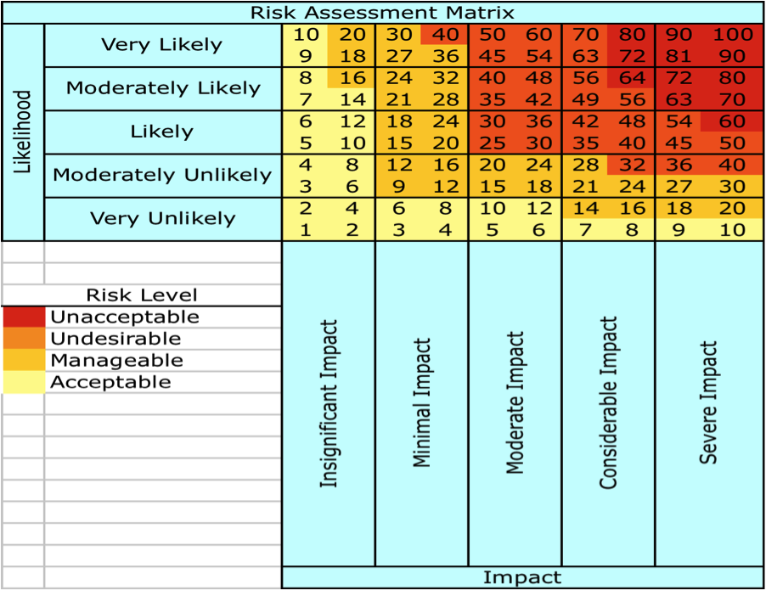

Of the nine internal risks previously listed, two land within the “Unacceptable” (Red) risk level, three land within the “Undesirable” (Orange) risk level, two land within the “Manageable (Gold)” risk level, and one falls within the “Acceptable” (Beige) risk level. These risks have been categorized according to their detrimental effects on the company resulting from legal issues and unsatisfied patients/customers as well as the likelihood of occurance.
- Unacceptable:
  - No password change (90)
    - HIPAA requires “privacy of certain individually identifiable health data, referred to as protected health information”
    - Potentially, any person could obtain an access code and view all protected patient information listed in the Our Responsibilities section of the “Notice of Privacy Practices” readable on Schryver’s webpage, which could lead to costly lawsuits against the company.
    - Potential fines range from $1,000 for a single offense to $1.5 million for repeat offenses or neglect
  - Unauthorized access to the PAC web based system (90)
    - The PAC web based system is where all digitized x-ray images are stored. Viewers can learn of any health issues evident and/or derive their own opinions based on observations – this also would be in violation of HIPAA regulations.
    - The current webpage allows access to the PAC web based system by simply creating a new username and account. A trial was done, and unauthorized access was granted.
      - Patty McBride was able to obtain a username and password because she works in an administrative capacity for nursing homes, although she should not have the ability to access this information because it is not pertinent to her job duties
  - Intake records incorrect information (81)
    - Both scenarios, although inconvenient and potentially harmful to the company, leave room for correction.
- Undesirable:
  - Order information is stored by date (48)
    - The information is stored by date which makes it incredibly difficult to locate a particular transaction. Employees frequently need to go through order information for billing purposes.
  - X-ray technician does not receive the x-ray assignment (36)
    - Dispatch would be responsible
  - X-ray technician does not pass off an x-ray assignment during shift change (42)
    - Technician would be held responsible
  - Dispatch does not notice an open Excel file (30)
    - These three scenarios may result in an x-ray request being incomplete or unread. This may lead to complaints or even legal and regulatory repercussions.
- Manageable:
  - Billing inputs incorrect information into Excel (15)
- Acceptable:
  - The IT executive quits (4)
    - This type of organizational change happens less frequently than other potential risks and is a natural part of business operations.
Of the eight external listed, three land within the “Unacceptable” (Red) risk level, two land within the “Undesirable” (Orange) risk level, two land within the “Manageable” (Gold) risk level, and one falls within the “Acceptable” (Beige) risk level. These risks have been categorized according to their effects on the company resulting from legal issues and unsatisfied patients/customers.
- Unacceptable:
  - Hacker passes firewall (81)
    - Potential fines range from $100 to $1.5 million
  - Nursing home passwords are not monitored (94)
    - Potential fines include, a minimum penalty of $1,000 per violation, with an annual maximum of $100,000 for repeat violations, or $50,000 per violation, with an annual maximum of $1.5 million for a maximum penalty
  - Nursing home loses faxed x-ray reading (63)
    - Essentially the same risks and repercussions apply here as previously seen in the Internal Risks assessment.
- Undesirable:
  - Radiologist does not receive digitized x-ray (35)
    - The radiologist may be held accountable and could have claims filed against him or the company.
  - Nursing home does not read current patient information (35)
    - The x-ray technician may x-ray/treat the patient for the wrong condition based off of out-dated records, which may result in death of the patient.
- Manageable:
  - The company system has a technical failure (24)
    - Minor setbacks may occur, but all critical data and necessary information is backed up in the new offsite data storage facility.
  - Natural disaster (14)
    - There is a low probability that natural disaster would be able to significantly influence Schryver’s business operations but is certainly possible. An offsite storage facility would be a great aid in this scenario in order to get operations up and running as soon as possible.

- Acceptable:
  - Loss of phone connection (2)
    - In this case, communications could be done through the use of cell phones and Internet based communication.

Risk Response & Control Activities

Risk | Score | Internal/ External | Control Objective | Decision | Control Activity
Passwords not monitored | 100 | Internal | Privacy | Avoid | Fingerprint password and employment contract
No password changes | 90 | Internal | Privacy | Avoid | Fingerprint password
Unauthorized person gains access to PACS | 90 | Internal | Privacy | Avoid | Stringent issuing requirements
Intake records wrong info | 81 | Internal | Accuracy | Share | Web based order system
Hacker passes firewall | 81 | External | Privacy | Reduce | Data encryption, stronger firewall
Nursing home loses faxed x-ray reading | 63 | External | Completeness | Avoid | Sent via web based system
Order info is stored by date | 48 | Internal | Accessibility | Avoid | Integrated database
Technician fails to pass off assignment | 42 | Internal | Completeness | Avoid | Web based order system

One of Schryver’s most important resources is its information assets; therefore, protecting these assets is of primary importance. We suggest the following controls as practical solutions to increasing both data privacy and data integrity:

Fingerprint password: Passwords are not monitored (100) & No password changes (90)
A fingerprint password control will help avoid privacy issues that are highly regulated by HIPAA. It is alarming that both internally and externally, employees are never required to change their passwords. This poses many issues and exposes Schryver to a great deal of risk. Employees, because of the weak risk awareness culture at Schryver, may share their password with unauthorized users. As mentioned in previous discussion of HIPAA, it is illegal for any individual to access patient information if it is not directly related to that person’s job. This is punishable by fines and ruins a healthcare company’s reputation. Since nurse’s passwords to the web-base system are never updated, a nurse can always access patient information from the Schryver website even after being fired. This is illegal as well. Fingerprint log-in ensures that only an authorized individual has access to confidential data and strengthens security at little cost to Schryver. Currently, Schryver has a “log-in with fingerprint” password option (figure 5). We suggest fingerprint log-in be mandatory instead of optional. Nursing homes are already equipped and familiar with how to use a Targus DEFCON Authenticator Pad (fingerprint verification is required to access insurance company information). It will cost money to store and retrieve fingerprint information; however, Schryver should be able to easily incur this cost especially when considering the benefit it provides in data securitization.
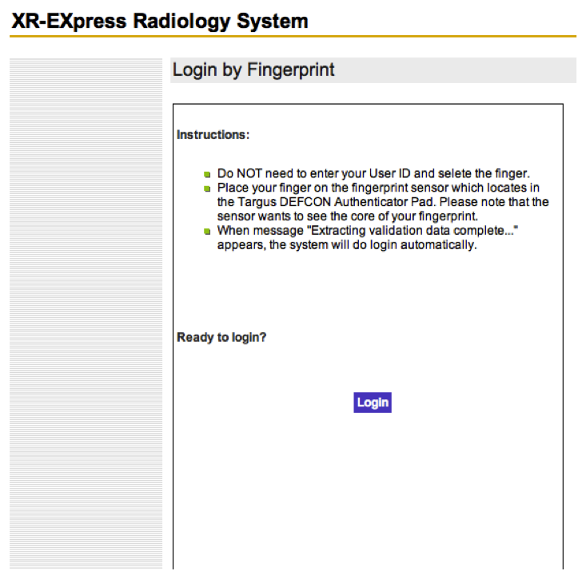

Service Level Agreement: Passwords not monitored (100) & Unauthorized person gains access to PACS (90)
Schryver’s customers should be required to apply security measures in accordance with the established policies and procedures within the organization. In other words, Schryver’s security should not be lessened due to involvement with external parties. Therefore, Schryver should ensure the required security controls are agreed to in a formal document known as a service level agreement (SLA). Primarily, the contract should require the nursing home’s management to notify Schryver within one hour of an employee quitting or being terminated. This way, Schryver’s IT can quickly remove granted access to confidential patient information. The SLA increases privacy because it ensures only authorized users have fingerprint access to information assets. The SLA should require the nursing home’s management to call Schryver’s IT department when requesting a nurse be granted fingerprint access to the system. A manager is expected to perform his or her job with a high level of integrity as well as having knowledge of which employees should be granted access to the system. This will limit the unauthorized users from getting access to information, like what happened in our example of Patty McBride gaining access to the system. Schryver should also be able to handle the costs of implementing a SLA. There are readily available SLA templates that cost around $200.00. However, we suggest Schryver hire a lawyer to form the contract to elicit the assistance of an experienced professional. Lawyer fees should not exceed $3000.00. Overall, these costs will be offset by the benefits because Schryver will be compensated for a nursing home’s breach of the contract and will avoid costly HIPAA fines.

Data encryption: Hacker passes firewall (81)
Currently, data is stored in Standard English. Data encryption would convert the plaintext into a secure-coded form of text called ciphertext. It cannot be understood without converting back via decryption to plaintext. This would protect data over the web-based network from improper inception. Also, information stored on company computers would be protected from unauthorized viewing and manipulation. Data encryption would make private data more secure overall.

Stronger firewall: Hacker passes firewall (81)
We suggest Schryver move to an application-level firewall. This application enforces correct application behavior, blocks malicious activity, and helps organizations ensure the safety of sensitive information and systems. In addition, the firewall can log user activity. Not only does the firewall protect against viruses, but it blocks undesirable web sites based on its IP address. Costs for this firewall are generally more than small to medium businesses are willing to incur. Schryver should look to build this IT goal into its intermediate IT objectives because it is a beneficial, but not immediately necessary security improvement. This is because Schryver is currently not a large enough company to be a target for hackers. However, if recent growth persists, Schryver may be under greater threat within five years and should explore implementing an application-level firewall.

Web based system: Intake records wrong information (81), Nursing home loses faxed x-ray reading (63), and X-ray technician fails to pass off assignment (42)
A real-time web-based system should be put in place to increase process efficiency and allow communication between the parties involved. The use of a web-based system would address the control objectives of accuracy and completeness. An online ordering system serves as a preventive control by ensuring that intake is receiving the correct information from the nursing home when an order is placed because Schryver does not physically have to record anything. The risk of Schryver receiving incorrect information is shared with the nurse placing the order. This is an improvement from the current method of placing an order over the phone while a person receiving the order at Schryver records the information. In addition to the risk of Schryver recording the information from the nurse incorrectly, there is a possibility that the nurse is providing the wrong patient information. This could be the result of incorrect or out-of-date medical records on paper. Sending false information will be virtually impossible because the patient information is linked to his or her name. Also, the nurse will have to confirm that the inputs on the order form are correct before final submission. In an online system that is monitored by all the parties involved, there is significantly less risk of the patient information being incorrect. In this regard, the web based system serves as a detective control. Also, allowing the radiologist, x-ray technician, and nursing home to communicate online makes sharing information easier. The radiologist would be able to send his analysis of the x-ray directly to the nursing home, as well as to Schryver to keep on file, instantaneously. Although the development costs of creating a system such as this would be fairly substantial, the long run benefits far surpass the costs. The current system is out-dated with many flaws and extremely severe privacy risks that could be reduced or eliminated with the use of a secure web based system.

Integrated Database: Order information is stored by date (48)
An integrated database system should be developed to make the data more useful. The database and web based system would be interrelated to allow for sharing of information between billing, the nursing home, and order processing at Schryver. The use of a database would address the control objective of accessibility. The current system in place at Schryver for storing orders uses a separate excel file for each day of operations. This makes it very difficult to access information from the past. Also, there is no easy way of looking up an individual patient’s history, which is an obvious problem. In addition, the systems from intake, dispatch, and billing do not talk to one another. This makes it very possible for the different departments to record different information regarding a single transaction. This makes looking up past transactions extremely difficult because there is no matching data. The use of an integrated database ensures the nursing home, x-ray technician, radiologist, and billing department will all be receiving the same information. When a nurse enters the patient name, other pertinent information such as social security number, health insurance provider, and medical history will automatically be attached. Time will not be wasted trying to fix discrepancies over a transaction. It will be possible to look up orders by nursing home, the nurse’s name that placed the order, order date, patient name, insurance provider, x-ray technician, or radiologist. This makes the information much more useful to the parties involved. The database and web based system would be highly correlated. Building up the database with information for each individual nurse, patient, x-ray technician, and radiologist would be time consuming. However, it would greatly reduce risk for Schryver, save time and money in the long run, and allow for much smoother day-to-day operations.

Information and Communication
A large problem with Schryver today is that the company has multiple systems that do not talk. The billing department uses the Medisoft system which does not communicate with intake’s Excel files which does not communicate with the x-ray technician and radiologist on the PAC system. This is a waste of time and resources and leaves room for error. Under the web based system and database, the nurse, billing department, x-ray technician, and radiologist would all have the same patient information. Another huge problem at Schryver is privacy. Under the current system, there is an unacceptably high risk of patient identity theft. Gaining access to personal information is far too easy under the current system, as discussed the section above pertaining to risks. There are obvious flaws within the system that could result in severe penalties for violating the Health Insurance Portability and Accountability Act (HIPAA). An integrated database and web based system would help correct the issues that Schryver faces every day.

HIPAA COMMUNICATION STRATEGY

Monitoring
Monitoring establishes minimum standards for each component of the enterprise risk management system. On-going monitoring is built into the normal, recurring operating activities of a business. Real-time, on-going monitoring is needed to make sure that orders are being properly received and services are being provided. Receiving accurate patient information and request for services is crucial for Schryver to be able to do its job. On-going monitoring would include confirming that patient information is up-to-date, ensuring orders are properly going through to the x-ray technician after the nurse submits the final order, and confirming that orders get closed and stored upon completion. Separate evaluations, such as quarterly and annual reviews, are another way to monitor the enterprise risk management system. Under the web based system and database, each party involved can be involved in monitoring the system to make sure it is operating as it was designed to. Monitoring would be done separately within each party involved, but the system would also require monitoring on an overall scale by the IT department at Schryver.

DATA MODELING

The data model shows the relationships between entities. Here we see that each nursing home can have one or more patients with one or more orders. Each nursing home can only have one address that corresponds to a zip code zone. Each order can only be for one nursing home, have one x-ray technician, one nurse, one patient, one x-ray technician, and one radiologist. This makes it easy to trace things such as who the x-ray technician was and which radiologist the x-ray was sent to. This can be done by the use of primary and foreign keys within the tables (ex: x-ray technician as a foreign key attribute of the radiologist).

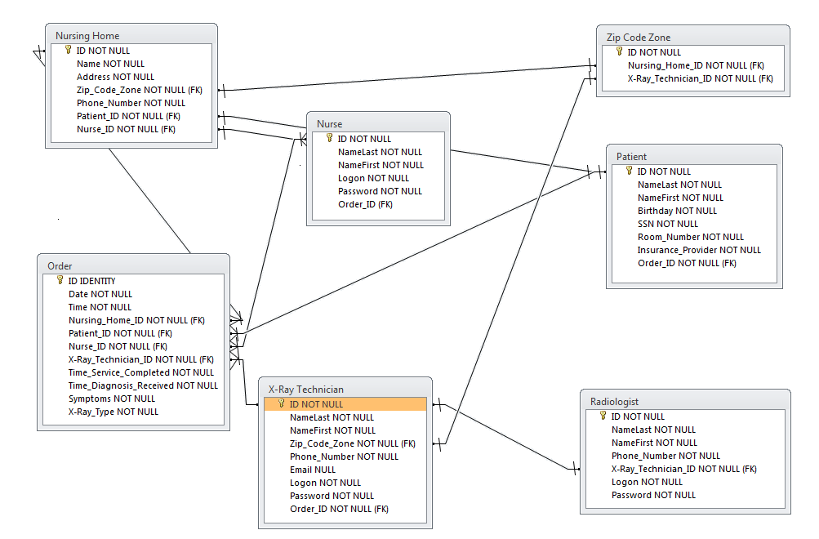

One of Schryver’s business objectives is to increase revenues by 10% per year. Consequently, Schryver has a KPI of filling 375 orders per week. Currently, without integrated data, Schryver has to open all the excel files, which are grouped by date, to see if this goal was met. This KPI was rarely tracked because of the inconvenience of doing so. Under the integrated database system we proposed, Schryver can input a query to receive a business report to measure this process performance (KPI). The query is as follows:
SELECT SUM ‘Order.ID’
FROM ‘Order’
WHERE Date BETWEEN ‘2010-11-15’ AND ‘2010-11-22’

This query would result in a single number being generated that represents the total number of orders received and completed over the course of that week.
SELECT ‘Order.ID’, ‘Date’, ‘Time’
FROM ‘Order’
WHERE ‘Date’ BETWEEN ‘2010-11-15’ AND ‘2010-11-22’
GROUP BY ‘Date’ DESC;

A partial business report that would be generated from the above query would look like this:
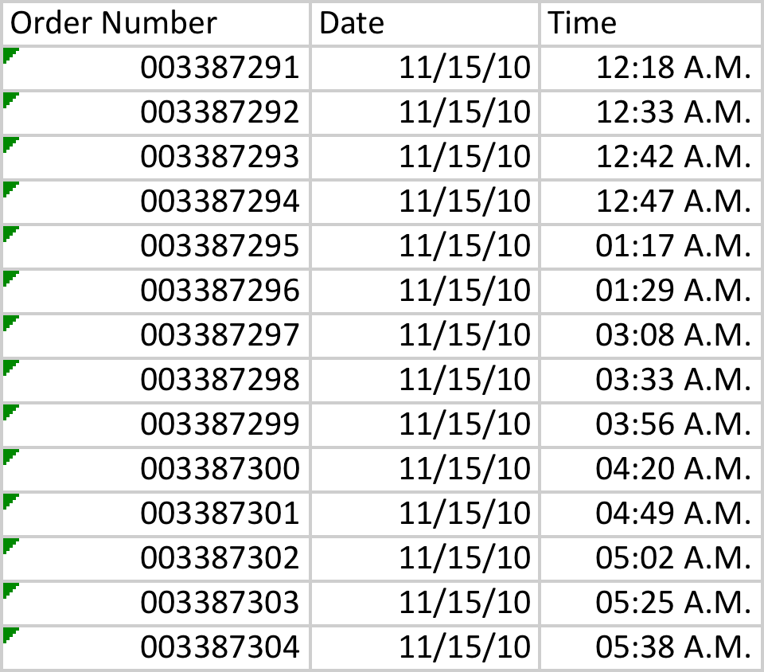
DATABASE VS. MASTER FILE SYSTEM

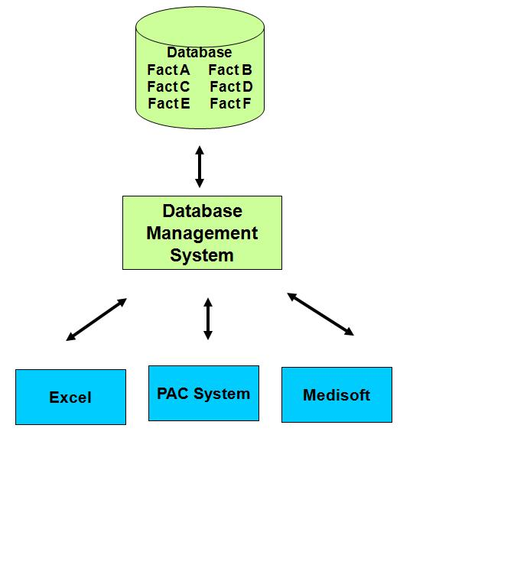
Schryver originally used a master file system with different files for separate activities such as billing, intake, and dispatch (Exhibit 4). This type of storage results in duplicate data entry, difficult system integration, and errors between the double entry data, known as update anomaly. The data base system (Exhibit 5) uses centrally coordinated files that can be accessed through the database management system by all employees. Now, all employees can access the same information in one location. This reduces the amount of entry errors (insert anomalies, delete anomalies, and update anomalies), duplicate data, and difficulty of locating data.

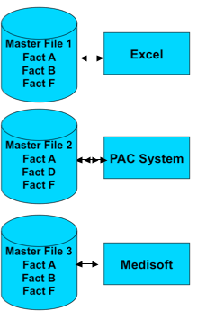
Exhibit 4 – Master File System Exhibit 5 – Database Management System

DISASTER RECOVERY PLAN
Business Continuity Plans (BCP) and Disaster Recovery Plans (DRP) are imperative for continuing critical business functions in the case of disaster. BCP/DRP help assess potential risks and outline what must be done in the case of disaster or information loss. These plans must take into consideration current legal regulations and contractual agreements.

The most effective back-up system for Schryver Medical is the Multiple Generation method. This type of back-up method updates critical files and information weekly, which are uploaded to an offsite storage facility. The storage facility will be a cold site storage facility where only basic business functions can be performed. This will help reduce costs associated with storage and is appropriate for Schryver’s basic business needs.

The Business Continuity Plan and Disaster Recovery Plan will:
- ensure safe storage of all patient information,
- aid in recovery of lost patient information,
- aid in clarification of all insurance related collection disputes, and
- provide chronological x-ray information history

Implementing offsite storage will help increase customer service response time in the event of a system failure and provide an organized back-up compilation of old records. Since Schryver does not have extremely complex data to store, the costs of establishing offsite storage should not be too high. The costs of losing all the data in the event of a system failure far outweigh the costs of maintaining offsite storage. There will need to be separate storage drives for intake, dispatch, x-ray, and billing information in order to preserve the integrity of the information being backed up as well as neutral technicians to reduce any conflict of interests that may arise.

Offsite data storage can be done online as opposed to acquiring a building and investing in adequate data storage and facility maintenance. Online storage rates are approximately $10 per gigabyte per month not including software installation, monitoring, tech and customer support, and training. On average, we can expect to store between 250-400 gigabytes of x-ray images and 10 gigabytes of patient information, resulting in approximately $400 in storage fees annually. These fees are insignificant when compared to possibly $1.5 million in HIPAA fines annually should the data be lost. Remote back-up drives back-up information automatically every night, resulting in no additional variable costs. In the health care industry where there are strict data regulations, the benefits of offsite storage highly outweigh the costs.
NEW PROCESS MAP

New Process Map Explained
The new process is made possible with the implementation of an integrated database and web based system, as discussed. In the old process, the nursing home would place an order with the intake personnel over the phone. The intake employee would then process and confirm the order. In the new process, the nursing home will log on to Schryver’s web based system to input the order data on a standardized form (Exhibit 6). With the web base order system the nursing home validates the order themselves by checking “Yes, the information above is correct” before submitting the x-ray order form. This click-on agreement limits Schryver’s liability of recording incorrect order information. In addition, the information will be more current because nurses can use online records as opposed to patient charts that could be out-dated. The system will assign an x-ray tech to complete the service based on a pre-established zip code zone. This data will be retrieved when the nurse inputs the entity “nursing home name” which will tie to the data value “nursing home zip code.” The dispatch employee will be eliminated from the process because the tech assignment is automated. The system will automatically notify the x-ray technician via text message. The technician will accept the assignment and the attributes “time of dispatch” and “technician name” will automatically be recorded. In the as-is process, the dispatch manually records the time the dispatch is assigned. The x-ray technician will, as with the old process, upload a digitized x-ray on the PAC system and the “time service completed” is stored. The radiologist will send the x-ray reading to the nursing home. When the nursing home accesses the file, the “time report received” will be documented. After the x-ray diagnosis is viewed on the computer in the nursing home the order will be completed. Intake employees will still exist should the nursing home choose to place the order over the phone. Zip code assignment will be automated so the dispatch and intake departments can be combined.

Benefits of the New Process Map
The suggested process map has numerous advantages compared to the current as-is process. A primary benefit is that labor costs will drastically decrease because, with the automated technician assignment, the dispatch and intake departments can be combined. Since orders will primarily be submitted online, the number of intake employees can be reduced. These employees do not necessarily need to be laid-off. We suggest redistributing employees to expand the IT department. Increasing revenues is a secondary business objective; however, decreasing costs has a similar benefit.

Additionally, patient information will be current, increasing the accuracy of the service (a primary business objective). Also, the order information is placed solely by the nursing home, so incorrect information is at the fault of the customer. The automated process will be faster with fewer departments and human interaction, which promotes the business objective of providing services in a timely manner.

The system will automatically update the “time of dispatch”, “time of service completed”, and “time report received”. This decreases human error, eliminates orders going unfilled, and improves customer relations enhancing all business objectives. Also, the report will no longer be faxed, and, instead, can be accessed online. Reports will no longer be lost.
Exhibit 6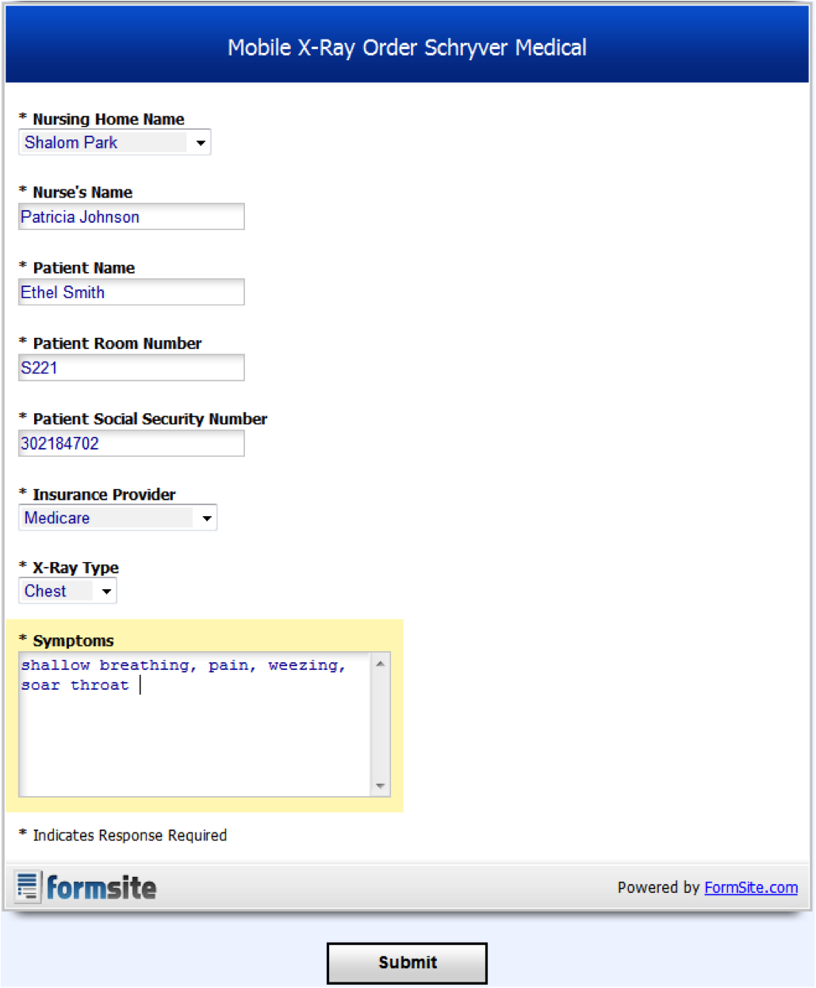

New KPI Suggestions
Schryver Medical tracks KPI’s that address the performance of individual steps, yet fail to measure the success of the mobile x-ray process as a whole. This means Schryver focuses on parts of the process, such as phone answer time and technician service time, but does not measure the steps collectively. What you measure is what employees will see as important; current KPI’s sacrifice striving to enhance the process as a whole. Measuring the entire process would coincide better with the company’s broader business objectives, such as being the primary X-ray provider in Colorado and growing revenues by 10% per year. Tracking such measures would alert Schryver when the mobile x-ray process is underperforming. A quick response to address problems in a time-effective and efficient manner is a strong competitive advantage. We suggest Schryver measures the following KPI’s:
- Receive 375 orders per week.
- Grow nursing home mobile x-ray service market share by 2% per year.

Objectives in relation to KPI’s
Receive 375 orders per week.
Schryver’s primary business objective is to be an adequate alternative to hospital visits. To ensure nursing homes are still using mobile x-ray services, the number of orders being received should be consistent; an inconsistency would suggest Schryver’s process is inadequate because customers are either going to the competition or using hospital services.

Grow nursing home mobile x-ray service market share by 2% per year.
This measure ensures that the mobile x-ray process is contributing to the objective to growing company revenues by 10% each year. If the growth rate is less than this, the process needs to be evaluated.

CONCLUSION
Throughout this report we have highlighted numerous high-risk activities related to unauthorized access to personal patient information, storage of information, and means to better achieve Schryver’s primary business objectives. The biggest change we suggest for Schryver Medical is implementing a web based system and integrated database that will eliminate many of the risks the firm faces and improve process efficiency. Additional controls have been suggested as well to further reduce the chances of error and better protect secure information. Furthermore, these controls will help streamline operations and reduce unnecessary spending. Our proposed changes to the mobile x-ray process will ensure that the x-ray orders have been received, a technician has been assigned, the technician has completed the x-ray, radiology has received and interpreted the results to back to the nursing home, and that appropriate measures have been taken to receive reimbursement through the patients insurance agency. The offsite storage database will help safeguard patient information and protect against lawsuits resulting from violations of HIPAA regulations. These changes to the business will greatly improve performance and reduce the level of risk facing Schryver in the future.

