Demand Estimation Using Excel

SIMPLE LINEAR REGRESSION – DEMAND AS FUNCTION OF PRICE

John is the manager for the soft drink category at the Super Wal-mart at Broomfield, Colorado. John is aware that Coke Cola and Pepsi Cola, the two major brands of soft drinks under his management, are most frequently purchased by the local consumers; and these two brands are close competitors to each other. To develop a better understanding of the consumers’ sensitivities, John wants to estimate the price elasticity of Coke Cola, and he wants to focus on the best-selling SKU of the Coke product family, namely the 16 oz 24 can case. Luckily for John, there exists some variation due to the frequent price promotion for this SKU. More specifically, the price schedule of the SKU is as following:

Price schedule of 16 oz 24 can case of Coke
Regular price | 25.37
10% off | 22.83
20% off | 20.3
30% off | 17.76
40% off | 15.22

Initially John believed that the demand of coke is only closely related to its price. So he collected the data of price (in dollars) and quantity sold (in cases) for the Coke Cola, which is given in Table 1. John now uses Excel to make a scatter diagram of the quantity sold and price (to verify that a linear relationship does exist) and develop a regression equation to estimate this relationship.

Table 1

Week | Price of Coke | Quantity
1 | 25.37 | 45
2 | 25.37 | 40
3 | 25.37 | 40
4 | 25.37 | 43
5 | 22.83 | 41
6 | 20.3 | 45
7 | 25.37 | 45
8 | 20.3 | 46
9 | 17.76 | 47
10 | 25.37 | 41
11 | 22.83 | 40
12 | 17.76 | 42
13 | 25.37 | 41
14 | 25.37 | 44
15 | 25.37 | 39
16 | 20.3 | 43
17 | 22.83 | 43
18 | 25.37 | 42
19 | 25.37 | 43
20 | 15.22 | 45

Excel Instructions for Drawing a Scatter Plot
- Enter the above information in the Excel spreadsheet as shown in Figure 1 below.
- Click on Insert on the toolbar and then click on the Chart tab. The Chart Wizard will appear. In step 1 on select the XY (scatter) chart type (Figure 2), then click next.
- Your numerical data is contained in cells B2 through C21. So in step two enter your data range as shown in Figure 3, and click next.
- In steps 3 you can give your chart a title and label your axes. In step 4 specify where you want the chart to be placed. The finished chart is shown in Figure 4.
- After verifying that a linear trend does exist, determine the least squared regression equation.

Figure 1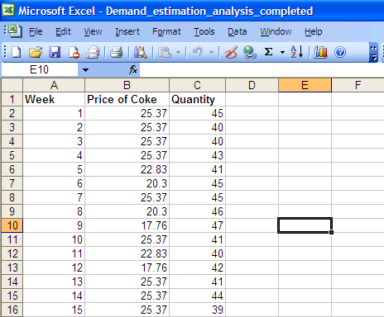
Figure 2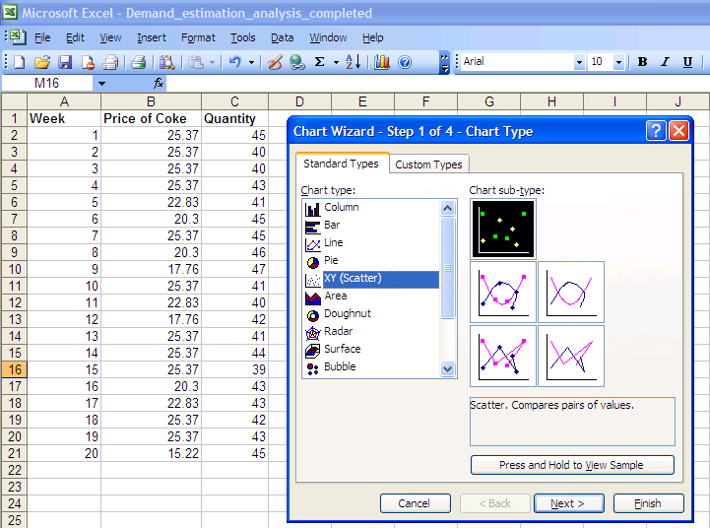

Figure 3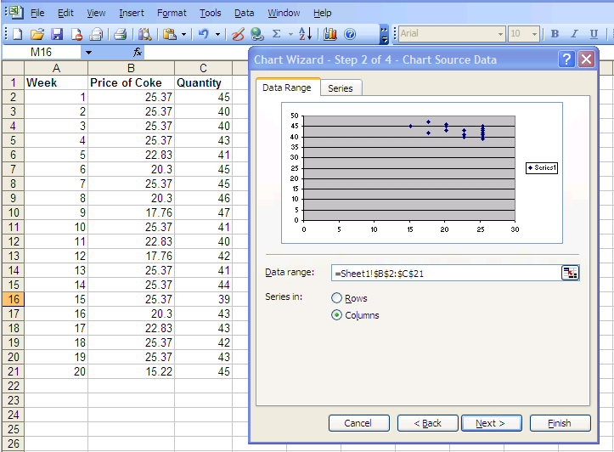

Figure 4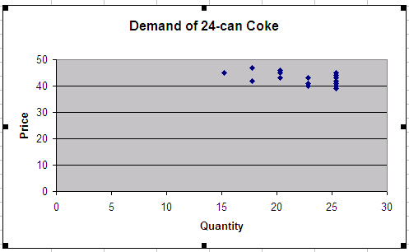

Excel Instructions for Regression Analysis
1. The Regression Macro (which is part of the Analysis ToolPak) is standard with Excel, however, it is not always active and available for use. Select the Tools menu, if Analysis ToolPak is active then you should see a Data Anaylsis item at the bottom of the menu. If this item is present skip to step 3.
2. If this item is not there then you need to do one easy step. Select the Add Ins option under the Tools menu, which brings up the following window.
Figure 5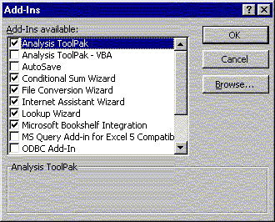

Click the Analysis ToolPak checkbox, then OK. Analysis Toolpak should now be present under Tools in the future.
2. Select the Data Analysis option under the Tools menu and select the Regression option (as shown below).
Figure 6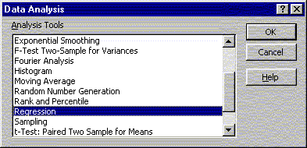
3. Your dependent variable (y) data is in cells C1 through C21 (including the variable name or label), and your independent variable data (x) is in cells B1 through B21. Click the labels box to indicate that the first row contains the variable names, and then click ok. See Figure 7.

Figure 7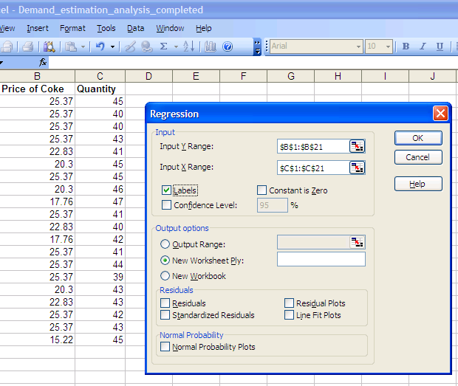

- A new worksheet will appear revealing the results of your regression analysis. The results from this analysis are shown below.

Correlation Coefficient

SUMMARY OUTPUT
Regression Statistics
Coefficient of Determination DeDetermination
Multiple R | 0.486148
R Square | 0.23634
Adjusted R Square | 0.193915
Standard Error | 2.906755
Observations | 20
 |  |  |  |  | P value for Anova Test
ANOVA
 | df | SS | MS | F | Significance F
Regression | 1 | 47.06812 | 47.06812 | 5.570702 | 0.029753
Residual | 18 | 152.0861 | 8.449227
Total  b₀ | 19 | 199.1542
 | Coefficients | Standard Error | t Stat | P-value | Lower 95% | Upper 95% | Lower 95.0% | Upper 95.0%
Intercept | 52.62478 | 12.58538 | 4.181423 | 0.000561 | 26.18389 | 79.06567 | 26.18389 | 79.06567
Quantity | -0.69391 | 0.294002 | -2.36023 | 0.029753  P value for t test for X₁ | -1.31159 | -0.07624 | -1.31159 | -0.07624
b₁

Interpreting Results

- In your second model summary table, you will find the Coefficient of Determination, R², and the Correlation Coefficient, R.

- The ANOVA table gives the F statistic for testing the claim that there is no significant relationship between your independent and dependent variables. The sig. value is your p value. Thus you should reject the claim that there is no significant relationship between your independent and dependent variables if p<α.

- The Columns below the Coefficients box gives the b₀ and b₁ values for the regression equation. The intercept value is always b₀. The b₁value is next to your independent variable, x.

- In the last P-value column of the coefficient output data, the p values for individual t tests for our independent variable is given (in the same row as your independent variable). Recall that this t test tests the claim that there is no relationship between the independent variable and your dependent variable. Thus you should reject the claim that there is no significant relationship between your independent variable and dependent variable if p<α.

II. MULTIPLE REGRESSION EXAMPLE

Now, it occurs to John that the demand of coke is also subject to factors that are other than its own price. Specifically, John would like to see whether (1) the national advertisement expenditure level of Coke and (2) the price of the 16 oz 24 can case Pepsi Cola also have significant impact on the demand of the 16 oz 24 can case Pepsi Cola. He then collected another 20 weeks of data with the additional information on Coke’s advertisement expenditure (in million dollars) and the price of Pepsi Cola (in dollars), which are provided in Table 2.

(It is worth noting that Pepsi Cola also has variations in price, as shown in the following price schedule)

Price schedule of 16 oz 24 can case of Pepsi
Regular price | 26.99
10% off | 24.29
20% off | 21.59
30% off | 18.89
40% off | 16.19

Table 2

Week1 | Price of Coke | Ad Expenditure | Pepsi Price | Quantity
1 | 25.37 | 0.568411685 | 26.99 | 50
2 | 25.37 | 10.2969667 | 24.29 | 48
3 | 25.37 | 7.166392557 | 21.59 | 47
4 | 25.37 | 2.95626479 | 18.89 | 48
5 | 22.83 | 8.155785796 | 21.59 | 47
6 | 20.3 | 7.783620011 | 26.99 | 53
7 | 25.37 | 6.875740786 | 24.29 | 52
8 | 20.3 | 8.298380414 | 26.99 | 53
9 | 17.76 | 7.142130105 | 18.89 | 53
10 | 25.37 | 3.860903898 | 16.19 | 45
11 | 22.83 | 0.645944922 | 26.99 | 46
12 | 17.76 | 3.406747527 | 26.99 | 48
13 | 25.37 | 4.557579882 | 16.19 | 46
14 | 25.37 | 8.59576811 | 21.59 | 51
15 | 25.37 | 7.394057886 | 18.89 | 45
16 | 20.3 | 9.146787194 | 26.99 | 51
17 | 22.83 | 9.852964788 | 26.99 | 51
18 | 25.37 | 5.856951748 | 24.29 | 49
19 | 25.37 | 10.63126611 | 18.89 | 50
20 | 15.22 | 7.251446949 | 26.99 | 53

To determine the regression equation for this scenario follow the same steps provided for Simple Linear Regression with the following modifications:

- Enter your multiple regression data in Excel as shown above.
- In Step 3, specify your dependent variable (y) data is in cells E1 through E21 (including the variable name or label), and your independent variable data (x₁ and x₂) is in cells B1 through D21. Click the labels box to indicate that the first row contains the variable names, and then click ok. See Figure 8.

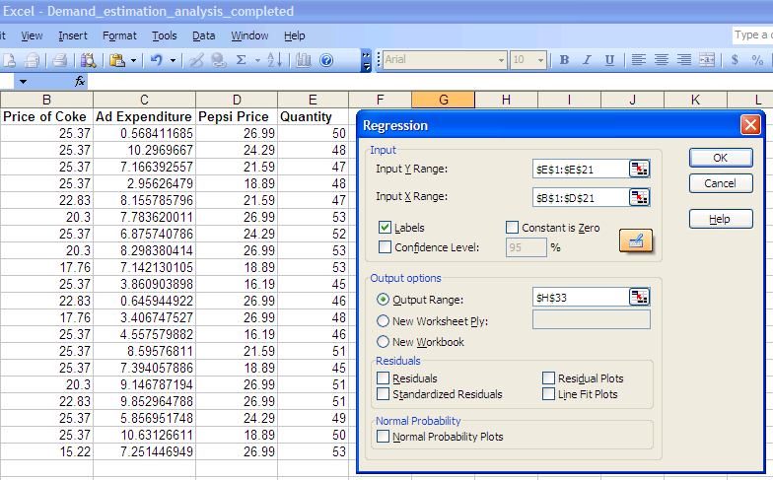Figure 8

Your output for this multiple regression problem should be similar to the results shown below.

SUMMARY OUTPUT
Regression Statistics
Multiple R | 0.70955
R Square | 0.503461
Adjusted R Square | 0.410359
Standard Error | 2.130054
Observations | 20
ANOVA
 | df | SS | MS | F | Significance F
Regression | 3 | 73.60593 | 24.53531 | 5.40767 | 0.0092117
Residual | 16 | 72.59407 | 4.537129
Total | 19 | 146.2
 | Coefficients | Standard Error | t Stat | P-value | Lower 95% | Upper 95% | Lower 95.0% | Upper 95.0%
Intercept | 48.63081 | 6.3247384 | 7.688984 | 9.2E-07 | 35.222968 | 62.038661 | 35.222968 | 62.03866052
Price of Coke | -0.3035 | 0.1711745 | -1.77307 | 0.09525 | -0.6663779 | 0.0593694 | -0.6663779 | 0.059369389
Ad Expenditure | 0.342937 | 0.1655882 | 2.071021 | 0.05489 | -0.0080947 | 0.6939678 | -0.0080947 | 0.693967798
Pepsi Price | 0.23406 | 0.1393504 | 1.679653 | 0.11244 | -0.0613493 | 0.5294699 | -0.0613493 | 0.529469871

Interpreting Results

- In your second model summary table, you will find the Adjusted Coefficient of Determination, Adjusted R², and the Correlation Coefficient, R.
- The ANOVA table gives the F statistic for testing the claim that there is no significant relationship between your all of your independent and dependent variables. The sig. value is your p value. Thus you should reject the claim that there is no significant relationship between your independent and dependent variables if p<α.
- The Coefficients box gives the b₀ and b_{1,} and b₂ values for the regression equation. The constant value is always b₀. The b₁value is next to your x₁ value, and b₂ is next to your x₂ value.
- In the last column of the coefficient box, the p values for individual t tests for our independent variables is given. Recall that this t test tests the claim that there is no relationship between the independent variable (in the corresponding row) and your dependent variable. Thus you should reject the claim that there is no significant relationship between your independent variable (in the corresponding row) and dependent variable if p<α.

III. ESTIMATION OF ALTERNATIVE DEMAND FUNCTION

John is quite convinced that the demand of coke is subject to factors that are included in the above analysis. Now John would like to try using an alternative (and more direct) model to estimate the price elasticity. In order to do so he takes the natural log of all the dependent and independent variables in table 2. The resulting data set is shown in Table 3.

Table 3

Week | Log of price of Coke | log of Ad Expenditure | log of Pepsi Price | Log of Quantity
1 | 3.233567374 | -0.564909325 | 3.295466427 | 3.912023
2 | 3.233567374 | 2.331849357 | 3.190064743 | 3.871201
3 | 3.233567374 | 1.969402398 | 3.072230245 | 3.8501476
4 | 3.233567374 | 1.083926576 | 2.938632682 | 3.871201
5 | 3.128075461 | 2.098727589 | 3.072230245 | 3.8501476
6 | 3.010620886 | 2.052021527 | 3.295466427 | 3.9702919
7 | 3.233567374 | 1.927999388 | 3.190064743 | 3.9512437
8 | 3.010620886 | 2.116060365 | 3.295466427 | 3.9702919
9 | 2.876948738 | 1.966011066 | 2.938632682 | 3.9702919
10 | 3.233567374 | 1.350901326 | 2.784393768 | 3.8066625
11 | 3.128075461 | -0.43704104 | 3.295466427 | 3.8286414
12 | 2.876948738 | 1.225758032 | 3.295466427 | 3.871201
13 | 3.233567374 | 1.516791755 | 2.784393768 | 3.8286414
14 | 3.233567374 | 2.151270002 | 3.072230245 | 3.9318256
15 | 3.233567374 | 2.000676689 | 2.938632682 | 3.8066625
16 | 3.010620886 | 2.213402691 | 3.295466427 | 3.9318256
17 | 3.128075461 | 2.287772404 | 3.295466427 | 3.9318256
18 | 3.233567374 | 1.767629289 | 3.190064743 | 3.8918203
19 | 3.233567374 | 2.363799292 | 2.938632682 | 3.912023
20 | 2.722610352 | 1.981201028 | 3.295466427 | 3.9702919

Your output for this multiple regression problem should be similar to the results shown below.

SUMMARY OUTPUT
Regression Statistics
Multiple R | 0.69907
R Square | 0.4887
Adjusted R Square | 0.39283
Standard Error | 0.044
Observations | 20
ANOVA
 | df | SS | MS | F | Significance F
Regression | 3 | 0.0296122 | 0.009871 | 5.09762 | 0.011505
Residual | 16 | 0.0309814 | 0.001936
Total | 19 | 0.0605936
 | Coefficients | Standard Error | t Stat | P-value | Lower 95% | Upper 95% | Lower 95.0% | Upper 95.0%
Intercept | 3.78166 | 0.3714503 | 10.18081 | 2.1E-08 | 2.994224 | 4.569102 | 2.994224 | 4.569102
Log of price of Coke | -0.11 | 0.0739163 | -1.4886 | 0.15604 | -0.266728 | 0.046664 | -0.266728 | 0.046664
log of Ad Expenditure | 0.02338 | 0.0126354 | 1.850108 | 0.08285 | -0.003409 | 0.050163 | -0.003409 | 0.050163
log of Pepsi Price | 0.13425 | 0.0631512 | 2.125801 | 0.04944 | 0.000372 | 0.268122 | 0.000372 | 0.268122

Interpreting Results

1. The way we read the regression outputs is very similar to what are described above.

2. The main difference is in the interpretation of the coefficient estimates.

