Marketing Deliverables
- Marketing Plan
- Logos
- Joint Marketing
- Save the Date
- Website
- Website Plan
- Press Release
- Marketing Contact Lists
Marketing Plan:
The Exceler8s Marketing team planned an advertisement plan with the help of Brian Allison and Kathryn Zwack.
The plan will focus on reaching out to the community for potential sponsors and participants to support TNC and the CO River Project by attending a 2 ½ day fundraising Festival.
The plan is in place to make up for a lack of advertising for the 1st annual Exceler8s Festival in Silverton.
Advertising should get the word out early enough to help drive the attendance numbers we are seeking for the event.
Advertising Methods:
- Develop advertising based around the purpose of the 2010 Exceler8s Festival and defining the qualities of the Mission Statement:
  - The purpose of this year’s Exceler8s II event will be to bring the community together in support of the Colorado Nature Conservancy’s Priority Rivers Project (PWP), a subset of the Colorado River Project. The event will focus on creating awareness of the project over the span of a two and a half day fundraiser event that will encompass everything from a relaxing and fun experience on the slopes of Winter Park to challenging guided tours through Jones Pass.
  - Mission Statement: Appreciate and celebrate the life experience of accomplishing achievements not thought possible by extending oneself physically and mentally in a team environment.
- Website:
  - Develop a promotional website that will handle registration, donation, information, cross promotion of sponsors and joint advertising partners, and direct sponsors and participants to the information they need to attend our event.
- Save-the-Date:
  - Email blast to let email list know about the event
- Other Email Blasts:
  - Update about Registration opening and bring attention to new details leading up to the event
- Fliers:
  - Develop fliers to distribute throughout the front range in stores, on campus, and at related events.
- Media:
  - Reach out to newspapers, TV stations, and magazines whether online or in print.
  - Develop PSAs, Calendar material, and articles to be featured.
  - Focus on finding free methods of advertising
  - $500 for feature advertising
- Joint Marketing:
  - Work out plans to market through related parties.
  - Advertise through TNC and its affiliates through website links and new letters.
  - Advertise through websites, word of mouth, and store fronts of related parties, including sponsors, Winter Park, Jones Pass, CU Foundation, and any other organizations willing to distribute our event information.
- Contact Lists:
  - Develop contacts to add to the master list held by Brian and Kathryn for email blast distribution.
Logos:

Logos used for Sponsorships, Fliers, Email Blasts, and Save the Date




Joint Marketing:
Banners for Snowforecast.com and other Joint Marketing Efforts


Save the Date:
The purpose of this document was to drive initial interest in the event by contacting parties on our email distribution list.
The actual Save-the-Date was sent out via an email blast which was developed by Kathryn Zwack, but the information was based on this file. You should have received this document on Nov. 20th.
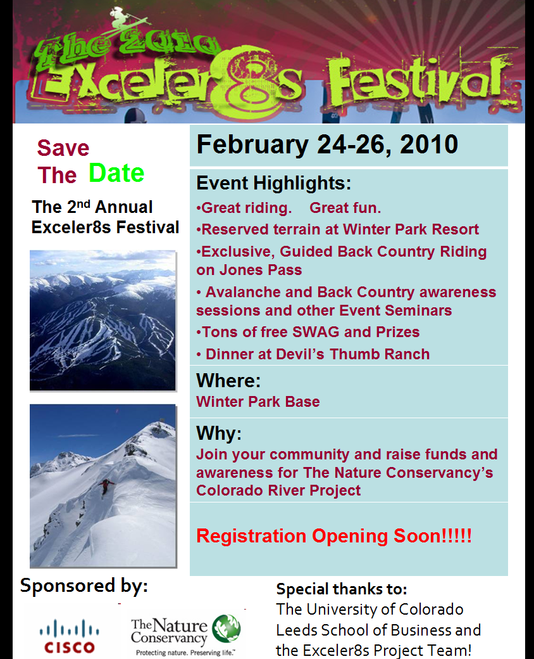

Website:
The website can be reached at www.exceler8s.com and is currently being forwarded via a redirect.
You will find that the Front Page, the About Page and its subsequent links are updated with content we have currently.
The remainder of the website is still a work in progress and will be mostly completed by the second week of December pending work outside the team’s hands.
Picture of our Website front page:
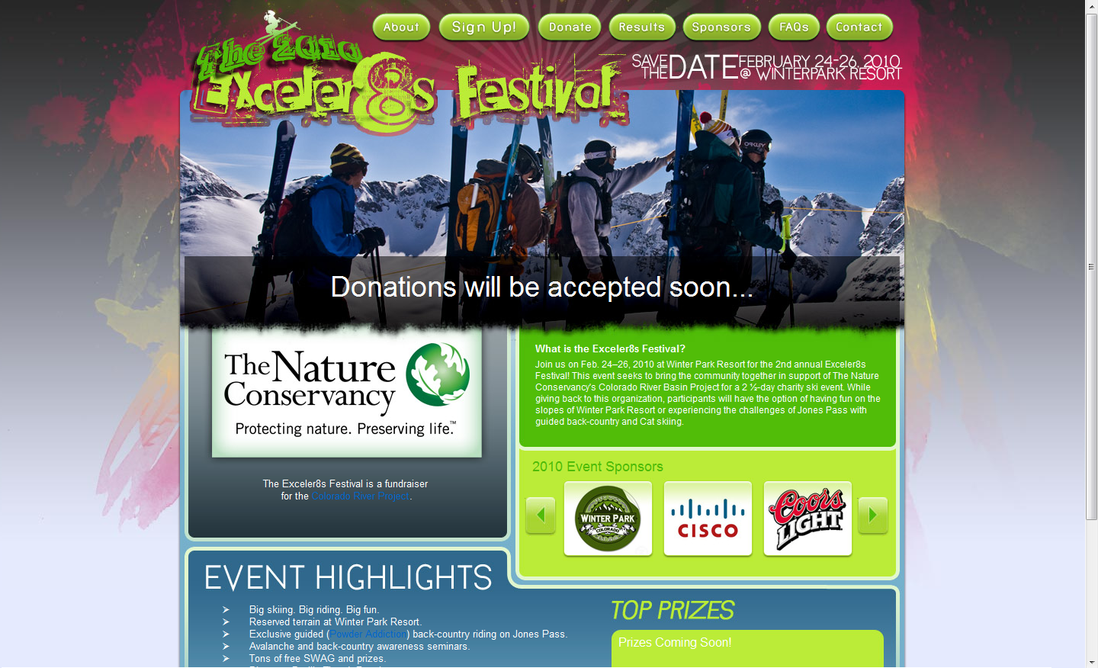
Website Plan:
  - The website and all major additions requiring technical expertise will be completed by Jon Hartman. The website content will be updated by Steve Bauer and to an extent the Sponsor Team for Sponsorship additions. The website will run off concrete 5 and is based on an original plan by Jon Hartman.
  - The website plan consisted of a template originally developed by Jon Hartman and can be seen on the webpage as the core template. All pages will have pictures, sponsor advertisements, cross-promotional links, and other forms of advertisement.
  - You will find a website plan document that lays out how website work has been distributed and the content expected for each part of the site. The final work is what you see on the website at this point.
  - Front Page: List the purpose of the event, event highlights, prizes, a link about TNC, sponsor banner, and Logo.
  - About Page: Will list the mission statement and team profile
    - Winter Park & Jones Pass info: List travel, hotel, and area information.
    - Event Details: List the Itinerary and specific details of the event.
    - Last Year’s Event: Discuss the history of the event.
    - TNC and the CO River Project: List what TNC does and the purpose of the project, and provide links to TNC content.

  - Sign Up: List the sign up process and have the registration program built into site.
  - Donate: List the Donation Process and have the donation process built into the site.
  - Results: List the results for highest donations and other event competitions.
  - Sponsors: List how to become a sponsor and have sponsor incentives listed.
  - FAQS: Put up questions regarding registration process, donation process, and the event.
  - Contact: House contact information for the event.
Press releases:
First Track and Elevations Outdoor Magazine
First Tracks Online Ski Magazine: Article Published on Nov 19th 2009
  - Boulder, CO - Brian Allison, a Boulder native who serves as Director of Business Development at Cisco Systems, used to make an annual pilgrimage to Silverton Mountain in southwestern Colorado with his brother and close friends. Together they would share a long weekend of steep skiing and male bonding. Then one day, Allison had had the notion to use that experience to give back to the community.
Out of that grew Exceler8s, an organization dedicated to inspiring individuals to accomplish physical and mental achievements in a team and community environment while also giving back to their communities. The group aspires to raise awareness of global issues of concern and provide funds for non-profit organizations to continue their work in those areas.
The group's first gathering was held this past April, when roughly 50 participants from Colorado, Texas, Massachusetts, and California gathered for two days of guided skiing and camaraderie at Silverton. Proceeds from a silent auction, private and corporate donations, totaling $13,000 were donated to The Nature Conservancy’s Colorado River Basin Project, which aims to restore native fish and streamside vegetation, control non-native vegetation improve flow patterns and protect river, spring and floodplain habitats. It also addresses issues such as water use and rights, climate change and ecosystem services valuation along the river's run from its headwaters to the Gulf of California.
This year’s annual Exceler8s Festival will be held Feb. 24-26, 2010 on Jones Pass and in Winter Park, Colo., near the river's headwaters. It will feature seminars on back-country/avalanche awareness, water sustainability issues in the Front Range and Grand County, and other related topics. Cat skiing will be offered for half days on Wednesday, and guided skiing for full days on Thursday and Friday through Powder Addition, a new backcountry skiing operation on Jones Pass. Participants with Exceler8s who elect to ski in more conventional surroundings can enjoy reserved terrain at Winter Park Resort at discounted prices.
A dinner with speaker and slide presentation (and footage of the day’s fun) will be hosted on Thursday night at Devil’s Thumb Ranch in Tabernash. A silent auction will be held during the dinner and participants will be encouraged to have friends and family donate to The Nature Conservancy’s Colorado River Basin Project. Organizers hope to at least double, if not triple, or attendance at the event this year.
For more information, visit the group's website, www.exceler8s.com.
http://www.firsttracksonline.com/News/2009/11/19/Skiing-Fundraiser-to-Raise-Awareness-of-Colorado-River-Project/
Elevations Outdoor Magazine Article
  - TBD - The article will be featured in their February issue
  - This article will be featured along with an advertisement for the event.
Marketing Contact Lists:
  - This is a list of the advertising groups we have been or plan to work with for the Exceler8s II Festival. We are contacting newspapers concerning feature articles and Calendars. We are contacting Radio Stations for Advertising announcements and PSAs. We are contacting TV stations for announcement opportunities as well.
  - There is a master list that is compiled by Kathryn Zwack for the project email list. Our current file is attached in our file.
  - The actual lists and contact information will be attached with our files.
  - Newspapers:
Colorado Daily, Daily Camera, Boulder Weekly, Denver post, Denver Daily News, Westward, Summit Daily News, Independent, Gazette, and Sky Hi News
  - Magazines:
Ski Tracks, First Tracks, Powder, Backcountry, Skinet, Ski Central, and Snow West
  - TV News Station:
9 News, CBS 4, ABC 7 News, KKTV 11, FOX 31, News First 5

