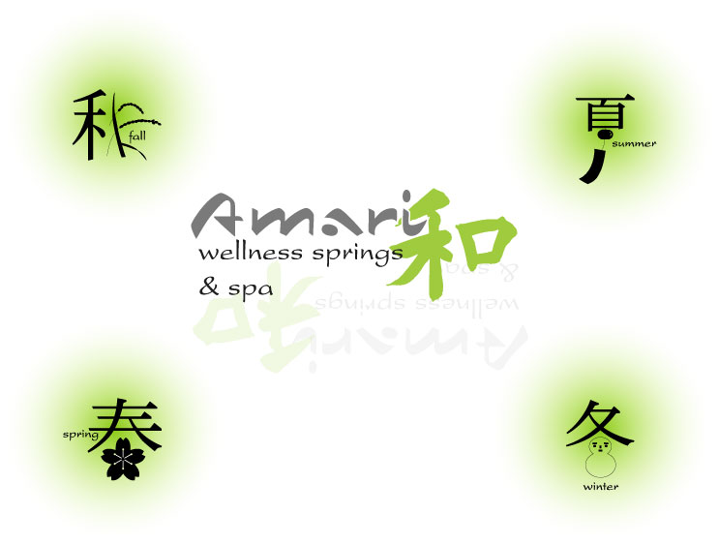

Austin Koo
Brendan Kroepsch
Sarah Peek
Russell Ward


Product Service Description

Upon setting foot into our lavish 7,500 square foot facility, the first thing to touch our guests’ senses is the soothing sound of cascading water from one of our numerous fountains. All those who enter Amari are cordially greeted, offered soothing herbal tea, and will receive a lavender and lemon hot towel to relax and cleanse their hands as their experience with Amari begins.
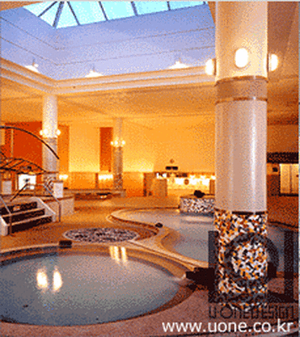
First time guests will be shown the entire facility by one of our knowledgeable receptionists. The tour begins in our locker room where each guest will be shown where the plush robes, towels and traditional bamboo slippers are provided.
From there, the guest will be shown our signature “Wellness Springs” area. Emphasis will be placed on the respective healing attributes of each of our four springs, as well as those of our two specialty saunas.

After the tour of our Wellness Springs, the guests are led under a stone archway into the spa treatment area of our facility and shown some of the treatment rooms.

Upon leaving the spa area they are shown the “Ohm Room”. This a darkly lit room, illuminated only by small candles behind Asian rice paper screens. The clientele use this place for a final moment of quietness, usually after getting a treatment and before re-entering the locker-room.
Before returning to the lobby, guests will be given a moment to peruse our retail center, items including skin/hair care products, health and wellness publications and various gift items, including living bamboo chutes, which can be put on guest accounts. Finally the guests are asked if there are any questions and handed our informative literature. The Amari brochure will communicate the following:
  - History of wellness springs as a longstanding Asian tradition.
  - Membership information and benefits.
  - A complete menu of all spa treatments along with our professional recommendation of what springs or saunas should come before or after each treatment.
  - A list of our partners throughout the community.

Wellness Springs & Sauna Rooms: This extravagant communal area will consist of four springs and two sauna rooms. All of which will aide guests in achieving the balance and wellness that is missing in their daily routine. The entire area will be available to guests at a flat rate and with no time limit. All springs and saunas will have a thorough description of the health benefits attributed to each and a digital readout of the current ambient temperature for ease of customer use.

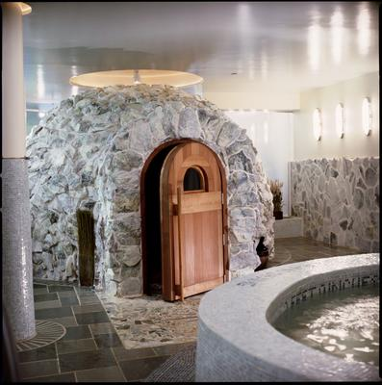
Springs Component: Japanese style Sake Spring, Massage Spring (whirlpool jets), Mineral Spring and a Cold Plunge (55 degrees). All springs will have seating around the outer edge so guests can relax or submerge themselves up to their shoulders. All Springs will have water flowing into them from a variety of beautiful fountains.

Sauna Component: Our guests will enjoy our specialty eucalyptus steam room as well as a Hwangto clay sauna, both of which provide a soothing escape, but are best when used in conjunction with the springs exemplified in the Amari Purification Program below.

Hwangto Clay Sauna Room
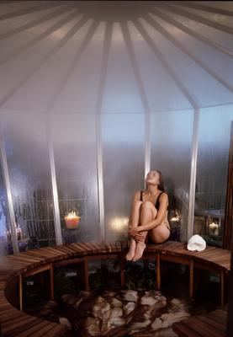
Spa Treatment Rooms: Our facility will have 10 treatment rooms. We will offer a unique twist on the traditional menu items of a day spa that include: massages, facials, body treatments, body scrubs, and body wraps. Amari will attract and maintain the best staff in the area to administer these services. Every member of Amari’s staff will have the necessary schooling and credentials for each respective position. Maintaining the well-trained staff will be achieved by giving all fulltime practitioners a benefits package including a membership to the Wellness Springs. We have also created various Wellness Combinations packages involving a combination of spa treatments complemented by our saunas and springs to create the maximum wellness experience possible.

Take for example our “Amari Purification Program. This purification journey will begin with our Hwangto Sauna to initially prepare the body at a comfortable low heat by beginning perspiration and toxin release. This is followed by our Eucalyptus Steam room to eliminate impurities, followed by a refreshing cool water plunge to re-balance the body. Next, an Organic Sea Salt Glow combined with aromatic oils will be used on your skin to stimulate circulation and refine your skin's natural texture. Then soak in our Seaweed Whirlpool or Sake Spring for the ultimate in skin nourishment and finally finish off with a calm meditative moment in our Ohm Room to relax before ending your experience with Amari.”
Eucalyptus Steam Room

High End Retail: “54% of all spa goers buy spa products during their visit” (2004 ISPA). Our retail center will be located just outside of the spa area. It will include traditional skin/hair care products as well as Asian themed gifts like our very own bamboo slippers and plush cotton robes. Among the health and wellness publications, and selection of assorted juices, there will be information on the current local artist’s art that adorns the walls of the facility that month.
The Sensual Environment
Sight: Our Asian theme will permeate the entire facility, from the pagoda over the Sake Spring to the living giant bamboo stalks that can be found throughout. The goal is to provide an ambiance of harmony and tranquility that is soothing to the eyes and helps visitors and members get a sense of an escape from their ordinary environment. To accomplish this, we will use natural materials and tones throughout the entire facility.
Sound: The natural and peaceful sound of running water will unify all the different areas of the facility.
Smell: The visitor will be greeted with subtle and soothing aromas such as eucalyptus and lavender.
Touch: To create harmony with the rest of the interior, we will utilize inviting textures and materials. From the bamboo slippers to the rice paper partitions, our guests will remain surrounded by the most inviting textures possible.

Feature Benefits Table 1A
General Facility
(“Guests say” based on market research)

Feature | Benefit | “Guests Say”
Wellness Springs | Healing pools and Saunas with specific health attributes | “A convenient and healthy increase in my quality of life”
All Female Members | Invites a more secure and relaxing environment | “I don’t have men hitting on me all the time like at the gym”
Retail Center | Guests may peruse a wide array of specialty/Asian products | “I can take some of the Amari experience home with me”
The Spa Area | Further emphasizing our dedication to total wellness through massage and other treatments. All treatments come with Free Pass to Wellness Springs area | “Their amazing treatments are a perfect compliment to the Wellness Springs”
Memberships | Once a week access to Wellness Springs. 15% off all spa treatments | “They know my name, I’m in every week!”
Flat Rate, No Time Limit | Passes to Wellness Springs are one price with no limit on how long guests may use the facility | “I can come when I want and stay for as long as I want, it’s just great”
Amari’s Environment | The core of Amari is its sensual theme that provide guests with an accessible escape | “I can leave my busy schedule for a soothing escape whenever I want”
* See Membership information Appendix 5

Feature Benefits Table 1B
Wellness Springs
(“Guests say” based on market research)

Features | Benefits | Guests Say
Sake Spring | Contains natural antioxidants, aides in digestion, and helps stressed bones and joints | “Wildly exotic and it helps in so many different ways”
Seaweed Spring | The mineral salts and vitamins in seaweed are naturally hydrating and rejuvenating to your skin | “My skin feels youthful, supple  and firm after using the Seaweed Spring”
Whirlpool Mineral Spring | Opens pores, cleanses the body, acts as a mild antiseptic and is vital for the growth and maintenance of bone | “I feel nourished inside and out, from my skin to my spine, this is my favorite”
Cold Plunge 55 degrees | A refreshing offset to all other areas of the spring, increases alertness and blood flow | “I use it last, it is like a shot of espresso that prepares me for the rest of my day”
Eucalyptus Sauna | Helps open sinus cavities and clears all upper respiratory system | “After just a few minutes my entire head and chest is clear”
Hwangto Clay Sauna | Produces same detoxifying perspiration as high heat saunas at a much lower temperature | “I usually think saunas are way too hot, this one is just right”

